Diretta Setup Guide

About Diretta
Diretta is a network audio protocol designed for high-quality network audio playback.
In a traditional network audio system, large blocks of audio data are transmitted over the network. These large data transfers can cause fluctuations in processing load and electrical current inside audio devices. Such fluctuations may introduce additional noise that can affect sound quality.
Diretta takes a different approach.
Instead of sending large chunks of audio data, Diretta transmits the audio stream as small, precisely timed packets. This allows the playback device to process the audio data in a more stable and predictable way, which helps reduce internal noise and improves playback performance.
A Diretta system consists of two main components:
- Diretta Host – The device that sends audio data over the network.
- Diretta Target – The device that receives the audio stream and outputs it to the DAC.
In most systems:
- The music player runs on the Host device
- The Target device focuses only on audio playback
This separation allows the playback device to operate with minimal processing load, which can help improve overall sound quality.

Diretta System Example
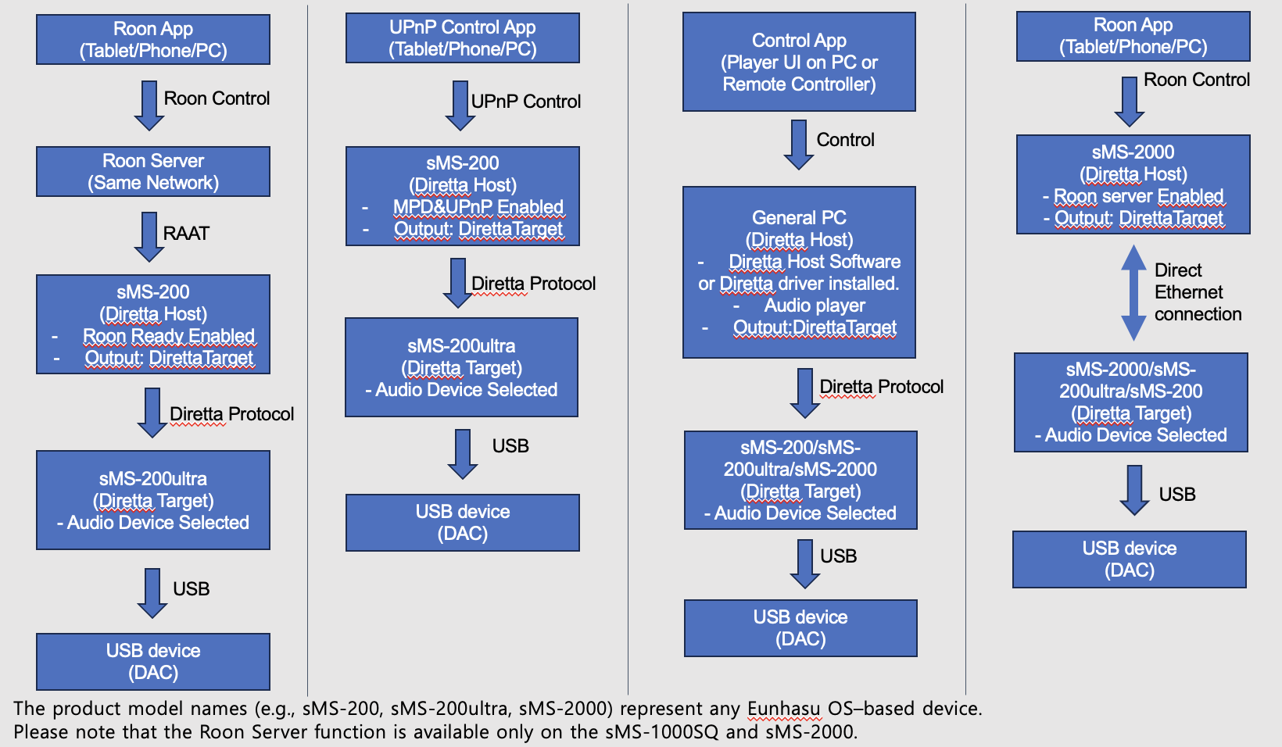

What is MTU and Why Diretta Uses It
MTU (Maximum Transmission Unit) defines the maximum packet size that can be transmitted over a network.
In most networks, the default MTU value is 1500 bytes.
Diretta allows the MTU size to be adjusted because larger packet sizes can sometimes improve transmission efficiency and reduce processing overhead.
However, MTU settings must match between devices in the network.
If the MTU values do not match, network communication problems may occur.
For this reason, MTU configuration options were added in later Eunhasu versions from 0.6.3 to allow advanced optimization of Diretta network performance.
It is recommended to first verify that Diretta operates correctly with the default MTU value of 1500 before changing the MTU setting.
In Eunhasu, the MTU value can be configured under System Config → Ethernet.
When increasing the MTU value, all devices on the network (Host, Target, switches, routers, etc.) must support the configured value.
Jumbo Frame (extended MTU) should only be used in network environments that support it.
Additionally, the maximum supported MTU value may vary depending on the device model.
- sMS-2000 / sMS-1000SQ : supports MTU up to 9014
- sMS-200 / sMS-200ultra : supports MTU up to 1500

How to Configure MTU for Jumbo Frame (sMS-2000 / sMS-1000SQ)
The following steps describe how to increase the MTU value to use Jumbo Frame on sMS-2000 / sMS-1000SQ.
1. First, verify that music playback works correctly via Diretta with the default MTU value of 1500.
2. Go to System Config → Ethernet and set the MTU value to either 4088 or 9014. (Only configure this in a network environment that supports jumbo frames.)
3. Click Save & Reboot to restart the system.
4. After rebooting, go to the Diretta Config page and configure the following :
- Diretta Target MTU : Set this to the same value as, or lower than, the MTU value configured in System Config.
- Diretta External MTU : Set this to the same MTU value configured on the Diretta Host device (such as a PC or another Eunhasu device).
5. Complete the remaining Diretta settings, save the configuration, and start Diretta to begin playback.

How to configure Diretta Target
1. Open Diretta Config.
2. Set:
Diretta Mode → Target
3. Select the Target Audio Device.
4. Click Save Changes.
5. Click Start.
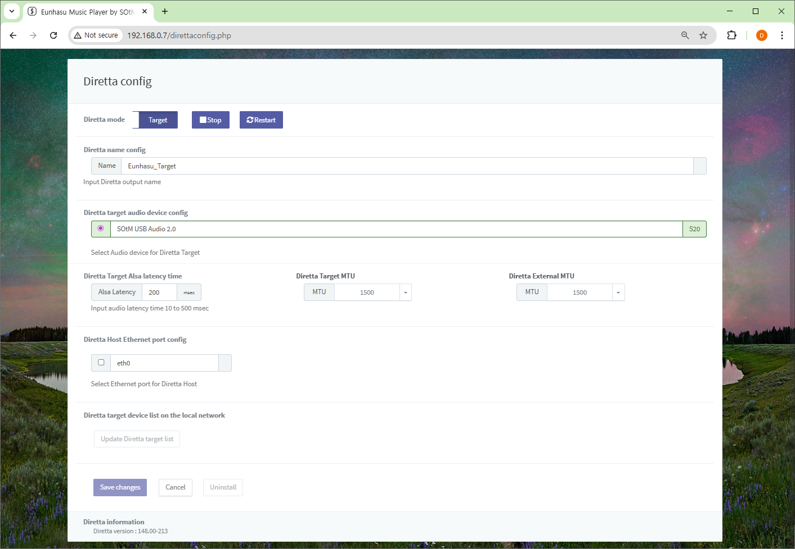

How to configure Diretta Host
1. Open Diretta Config.
2. Set:
Diretta Mode → Host
3. Click Save Changes.
4. Click Start.
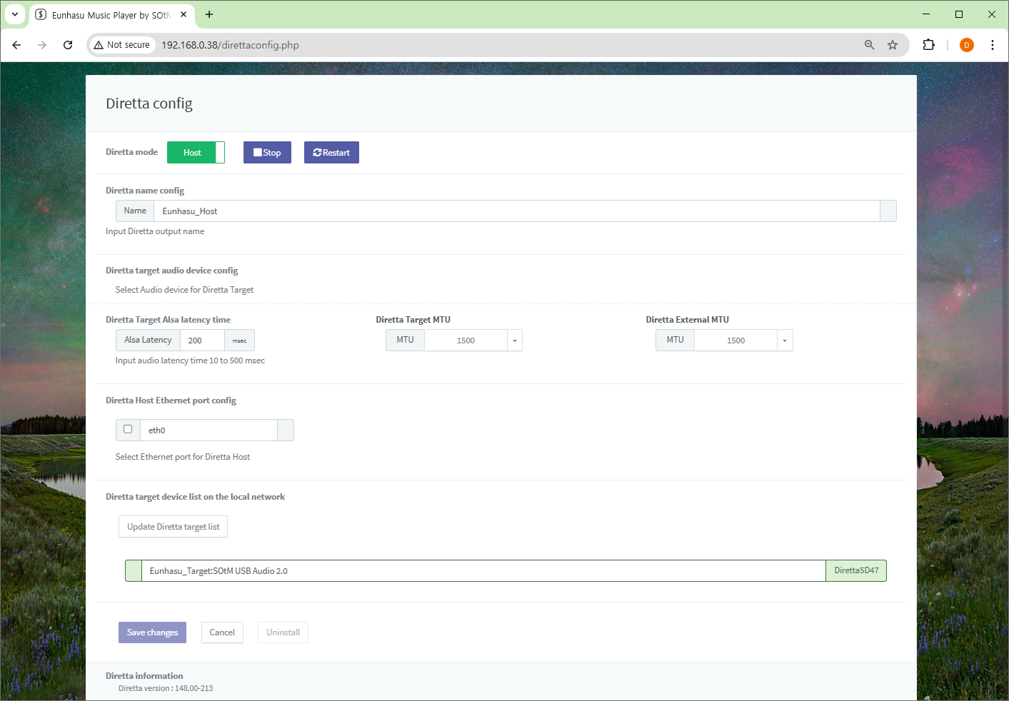

Selecting the Diretta Audio Device
1. Open Music Player Config.
2. Select the Diretta Target device.
3. Click Save Changes.
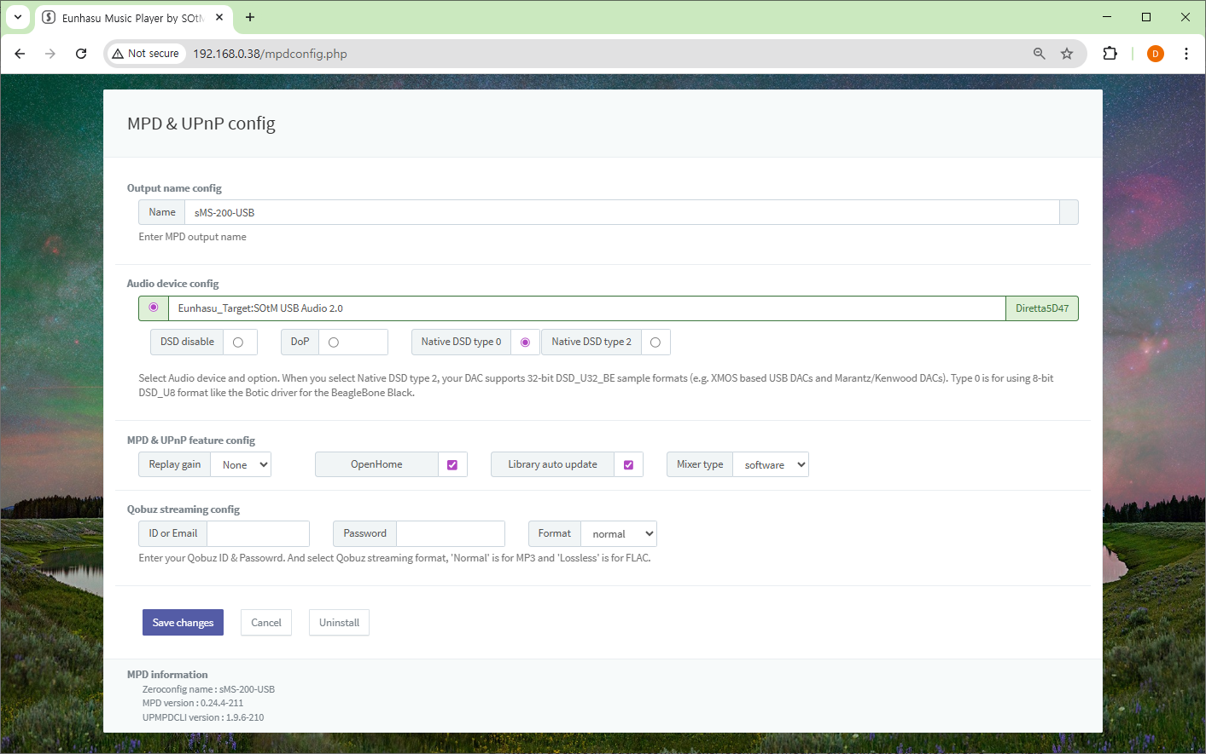

Using a Windows PC as a Diretta Host
Install the Diretta ASIO driver.
https://docs.sotm-audio.com/lib/exe/fetch.php?media=undefined:sotmasiodriver_3_148_4.zip
If using MS Mode3, install:
- WinPcap
- Npcap
Configure using SOtM ASIO Configure.
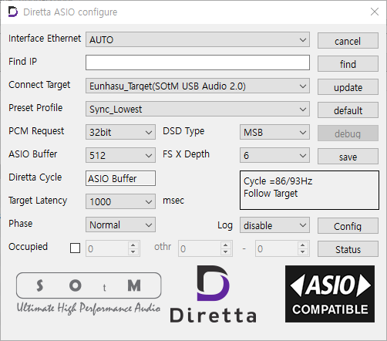
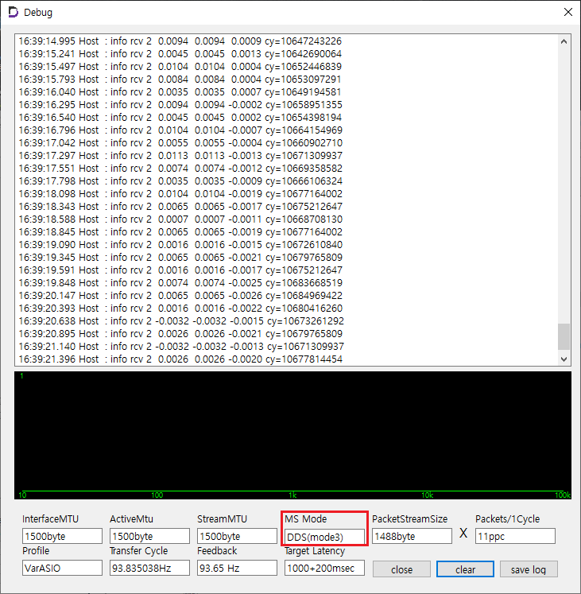

Direct Ethernet Connection Setup
Direct Ethernet connection allows the Diretta Host and Diretta Target devices to be connected directly using an Ethernet cable without passing through a router or network switch.
In some systems, this configuration may help reduce network traffic and interference, which can improve the stability of Diretta playback.
Example:
Diretta Host
│
Direct Ethernet Cable
│
Diretta Target
│
▼
DAC
This setup is optional and typically used for advanced configurations.

Required Equipment
Before starting the setup, prepare the following:
- Ethernet crossover cable
- USB Ethernet dongle or USB Wi-Fi dongle (if the device has only one Ethernet port)
If the device has only one Ethernet port, a USB network adapter is required so the device can remain connected to the main network while using the other interface for the direct connection.

Setup Steps
1. Update both the Diretta Host and Diretta Target devices to the latest Eunhasu firmware.
2. If your device has only one Ethernet port, connect a USB Ethernet adapter or USB Wi-Fi dongle.
3. Open the Eunhasu Web GUI on the Diretta Target device.
4. Go to System Config.
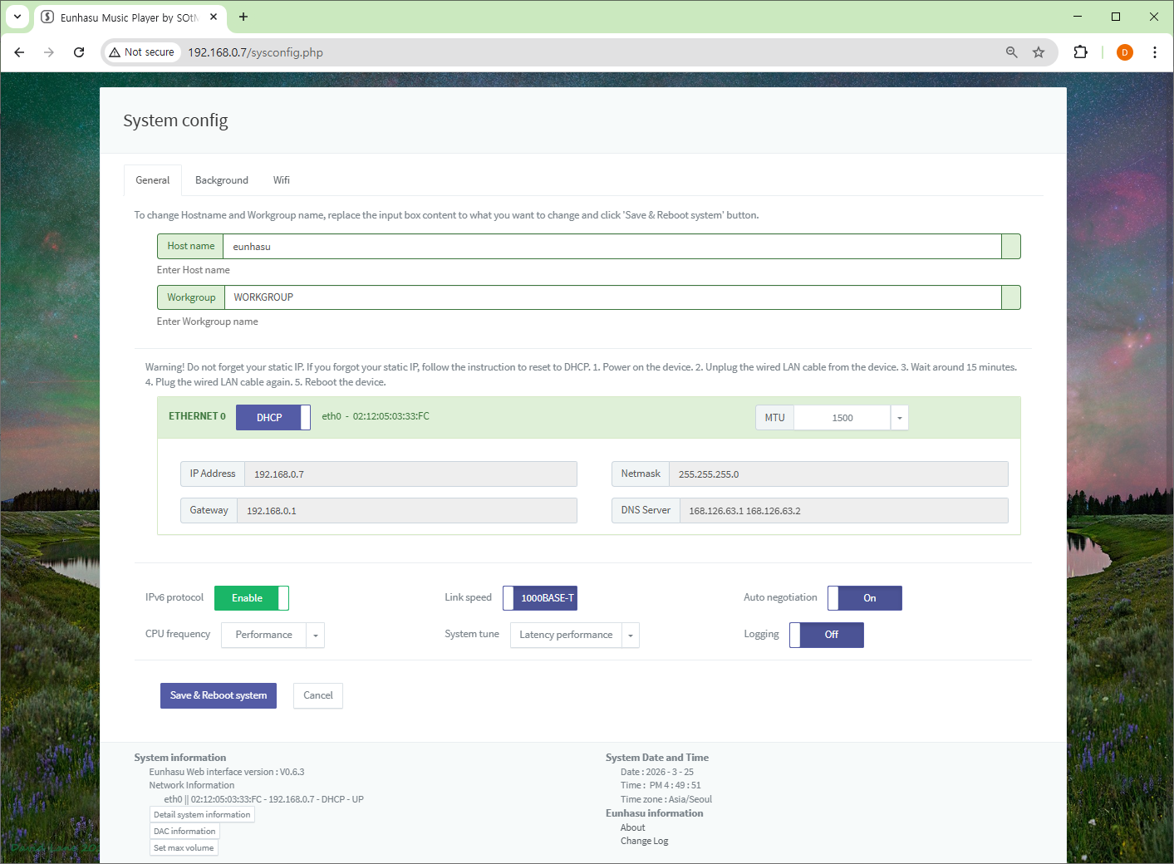
5. If using a Wi-Fi dongle, connect the device to your network.
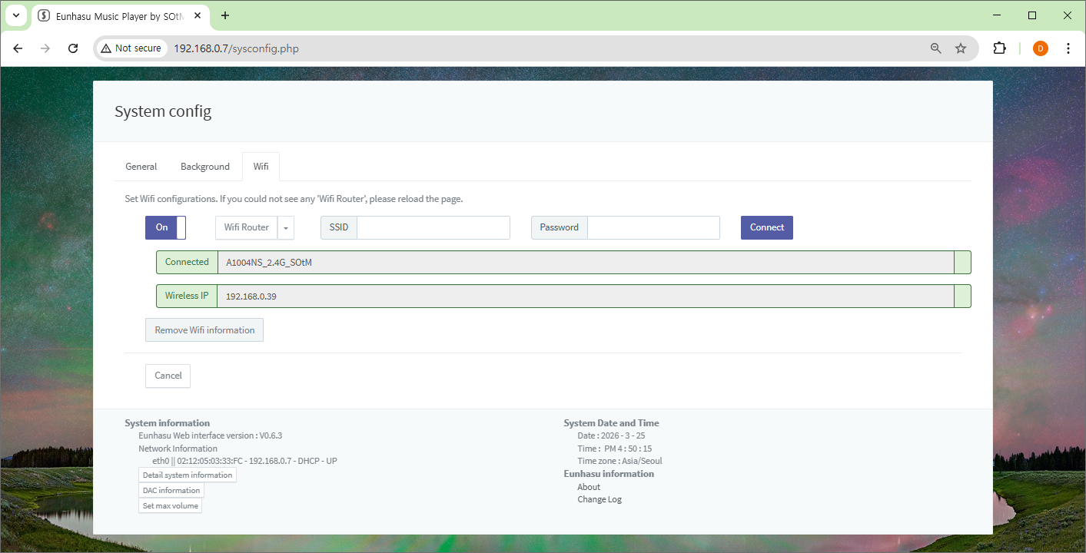
6. Access the Eunhasu Web GUI through the connected network interface.
7. Configure a static IP address on the Ethernet port that will connect directly to the Diretta Host.
Example:
IP Address xxx.xxx.xxx.nnn
Notes:
- The first three sections must match the Host network.
- The final number must be different from the Host device.
Network settings:
- Netmask: 255.255.255.0
- Gateway: leave empty
- DNS: leave empty
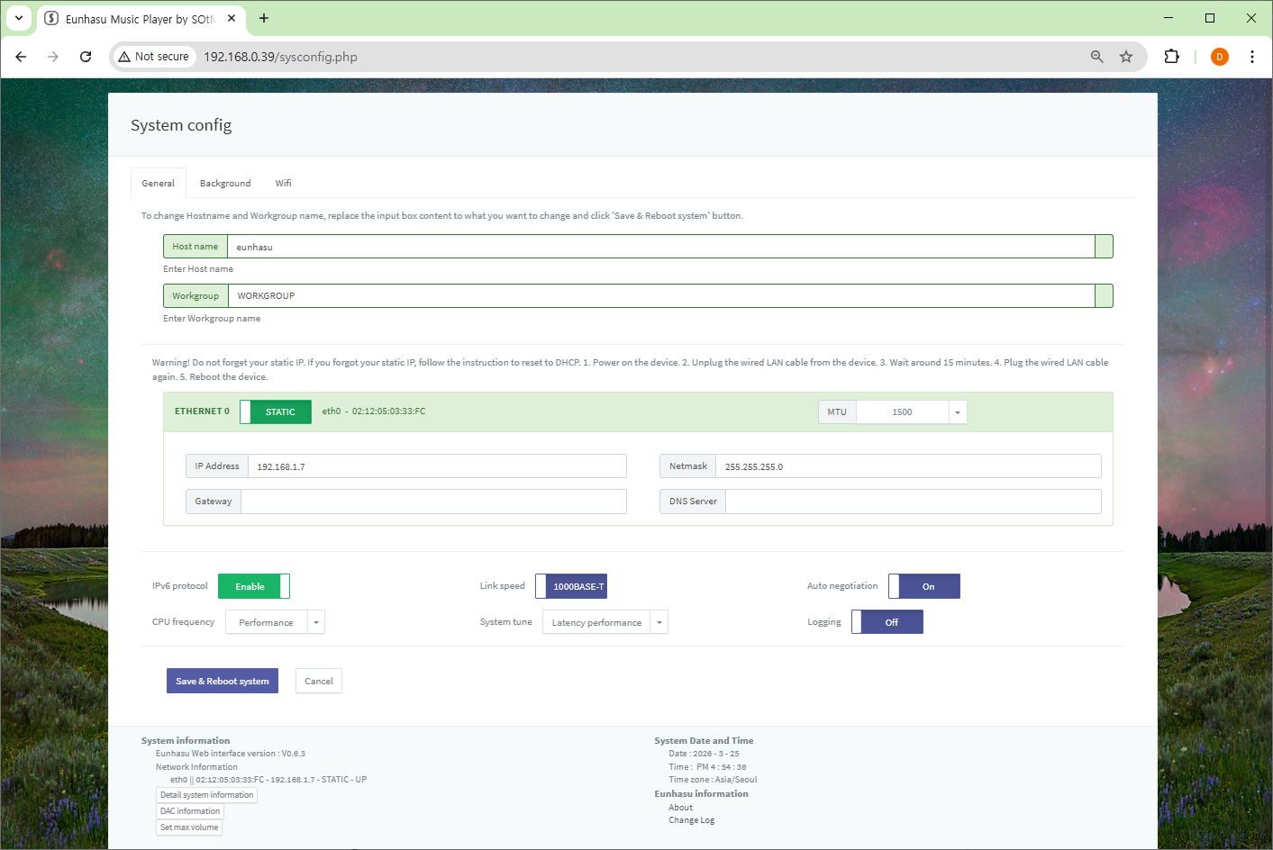
8. Click Save & Reboot System.
9. After rebooting, open the Diretta Config page on the Target device.
Configure:
- Diretta Mode → Target
- Select the Diretta Target audio device
Click Save Changes.
10. Click Start to activate Diretta Target mode.
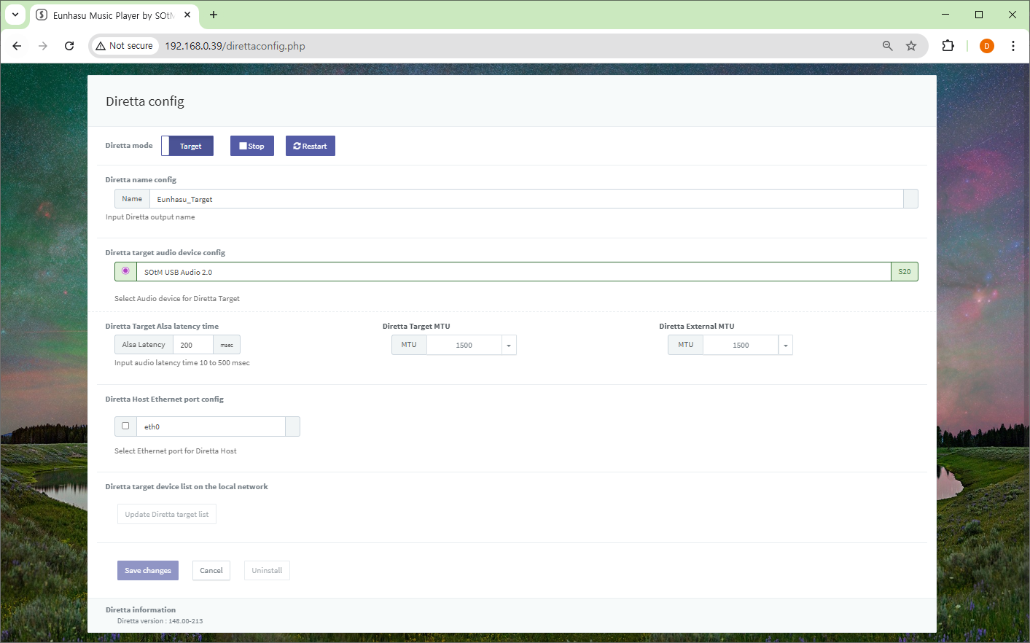

Important Notice
When configuring a Direct Ethernet connection, the Target device may temporarily connect to the network using Wi-Fi or a USB Ethernet adapter in order to access the Eunhasu Web GUI.
In this situation, the Diretta Host may detect two Diretta Target devices.
This occurs because the Target device becomes visible through two different network interfaces:
- the direct Ethernet connection
- the Wi-Fi or USB Ethernet connection used for configuration
Because of this, two Diretta Targets may appear in the Host device's Target list.
To avoid incorrect configuration:
- After finishing the Target setup, it is recommended not to use the Wi-Fi or USB Ethernet interface used for configuration.
- Use only the direct Ethernet connection between the Host and Target.
When the configuration is complete, close the Eunhasu Web GUI browser window completely to prevent accidental access through the temporary network interface.

Configure the Diretta Host
11. Open the Eunhasu Web GUI on the Diretta Host device.
12. Go to System Config.
13. Configure a static IP address for the Ethernet port that will connect to the Target device.
Example:
IP Address xxx.xxx.xxx.nnn
Notes:
- The first three sections must match the Target network.
- The final number must be different from the Target device.
Network settings:
- Netmask: 255.255.255.0
- Gateway: leave empty
- DNS: leave empty
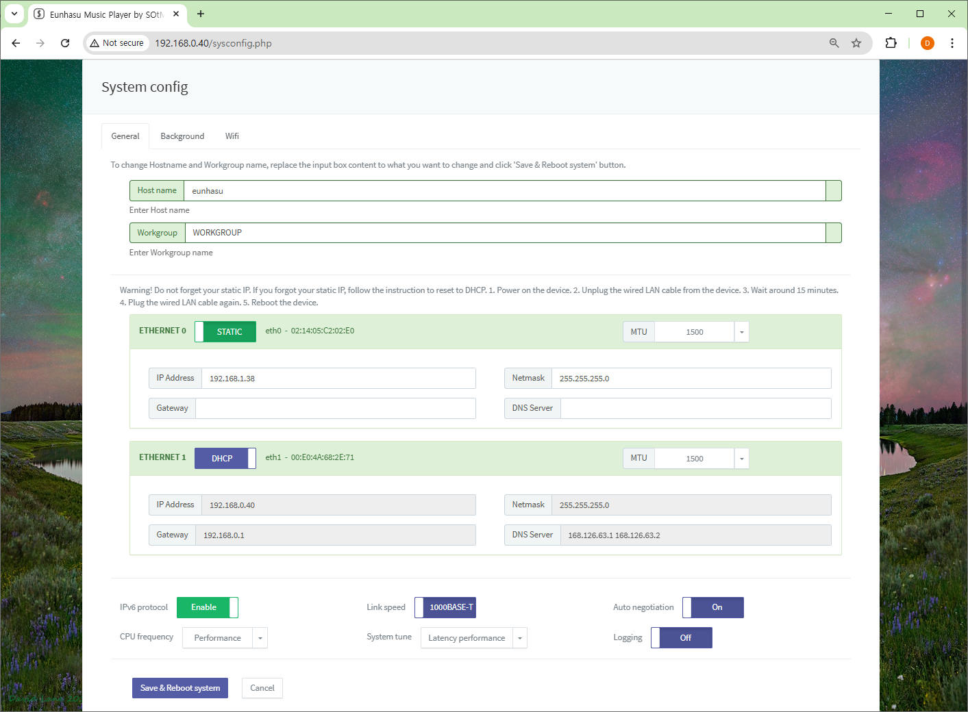(Insert Eunhasu 0.6.3 Host Ethernet screenshot)
14. Click Save & Reboot System.
15. Connect the Ethernet crossover cable between the Host and Target devices.

Enable Diretta Host Mode
16. Open the Diretta Config page on the Host device.
Configure:
- Diretta Mode → Host
- Select the Ethernet port used for the direct connection
Click Save Changes.
17. Click Start to activate Diretta Host mode.
After a short time, the Diretta Target device should appear in the Target list.
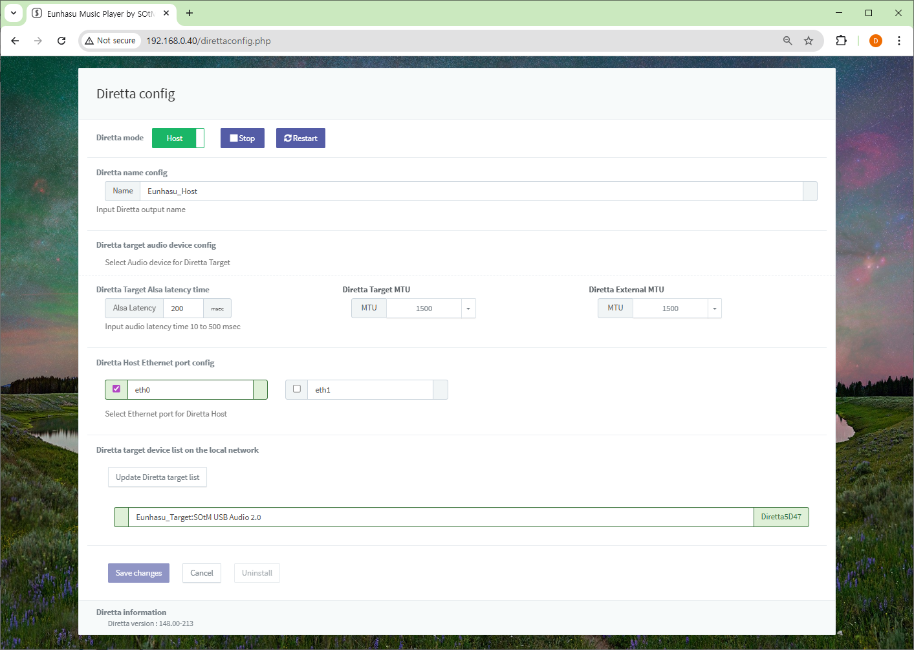

Select the Audio Device
18. Open Music Player Config.
19. Select the Diretta Target device as the audio output device.
20. Click Save Changes.
21. Start the music player and control it using your smartphone or tablet.

Troubleshooting
Target not detected
- Check that Diretta is running
- Check network connections
Playback stuttering
- Verify MTU configuration
- Restart Diretta

References
- https://www.sotm-audio.com/sotmwp/english/eunhasu-os-v0-6-3-alpha/
- https://www.sotm-audio.com/sotmwp/english/direttasettings/
- https://www.sotm-audio.com/sotmwp/english/how-to-set-up-a-direct-ethernet-connection-between-diretta-host-and-target-eunhasu-v0-5-9/

