CD Ripping
Supported file formats are aiff, mp3, wav or flac. When you set 'Automatic' ripping mode, ripping will started right after an optical disc is inserted to the drive. The ripped files path cannot be changed.
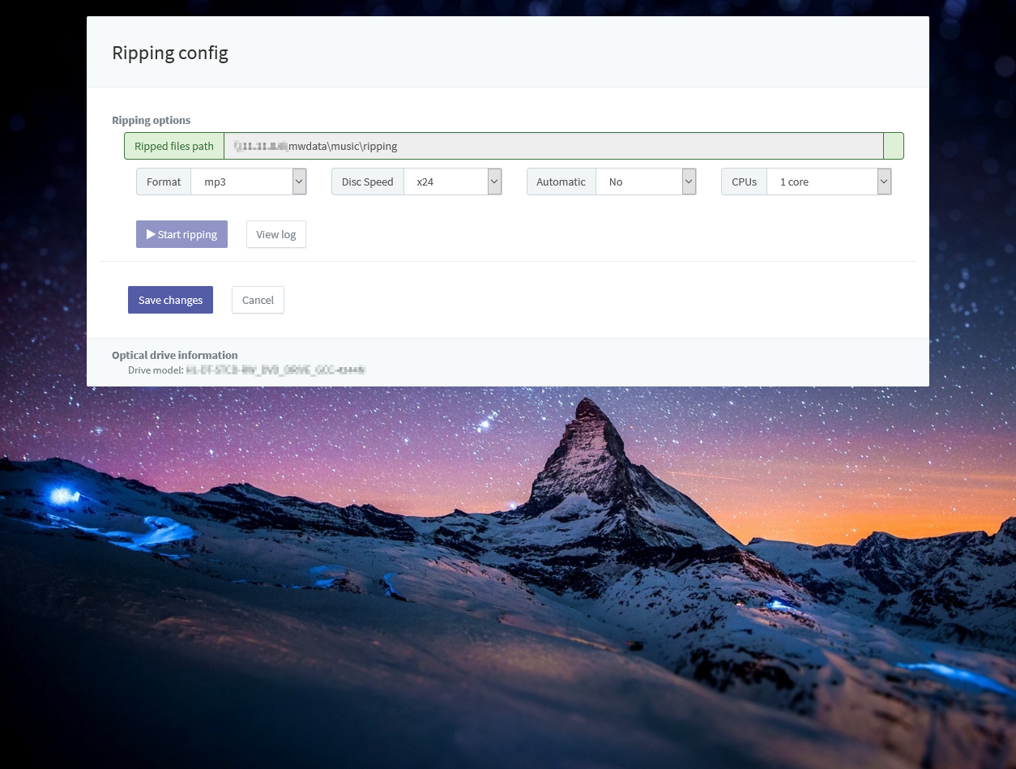
* Check the optical disk drive first before you try to rip.* The ripped file will be stored into “\\eunhasu\mwdata\music\ripping” folder.

