Burning mSD card image
How to load Eunhasu image to the micro SD card.

Windows OS

Preparation
- Download the latest Eunhasu image file and unzip it. Please note the image file is quite big. To download the Eunhasu image file, please send the serial number of your unit to the email address below: info@sotm-audio.com
- Download the imageUSB utility and unzip it, or try using Balena Etcher as it may work more reliably depending on your system.
- Press gently on the micro SD card in the micro SD card slot on the rear panel of sMS-200 to take it out, and insert it into a micro SD card reader. The micro SD card slot is “push-push type”, so after loading the image file to the micro SD card, you can insert the micro SD card back into the slot. Once it's inserted properly, you will hear a click sound.
- If the file name ends with .gz or .zip, you need to extract it using a separate utility.
- If you are not able to complete the process successfully after following these steps, please check the following video: https://youtu.be/ty_HN2gqJtQ. Some unzip utilities may not extract the files completely, and in some cases, the extraction process may need to be performed twice. The video was created by one of our valued customers. Thanks to HC for sharing it.

Run imageUSB
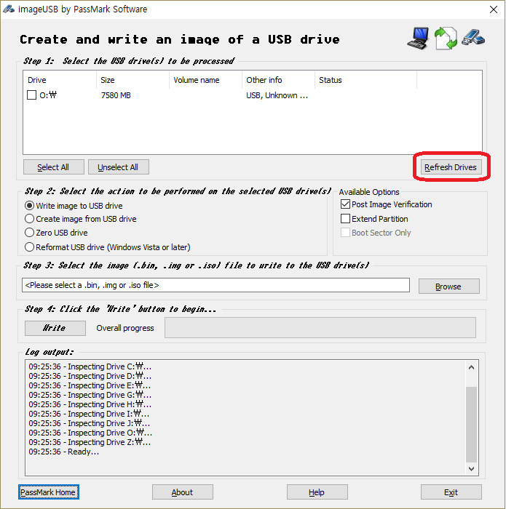
Run imageUSB. The connected USB device will be shown up. If the connected USB device is not shown, click 'Refresh Drives'.

Select a USB device
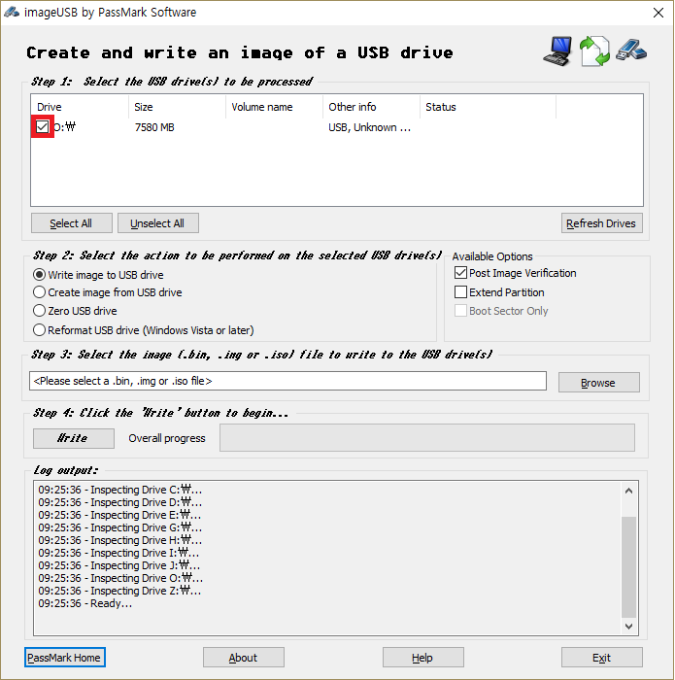
Select a USB device to write the new image file.

Select the new image file
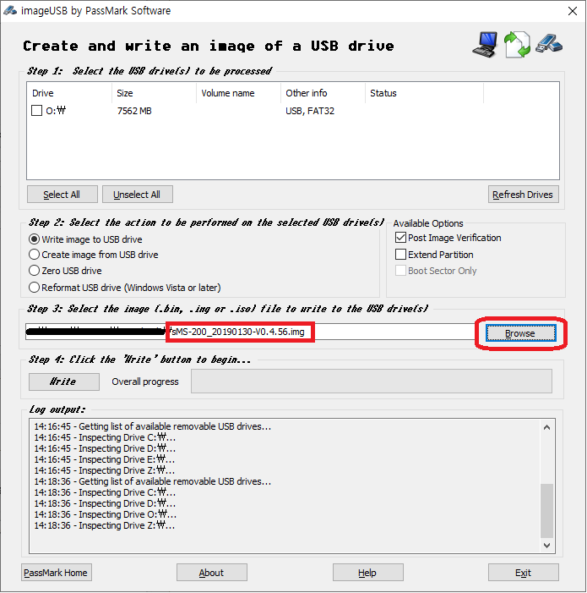
Click 'Browse' button and select the downloaded image file.

Write the new image
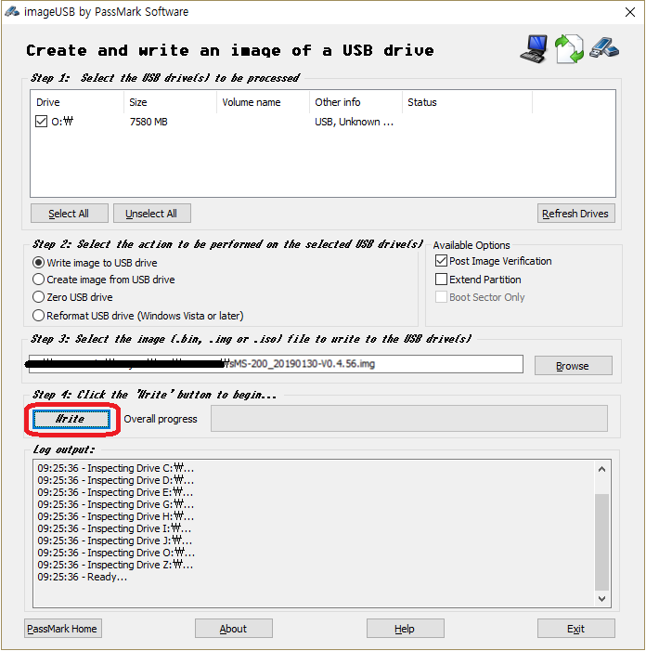
Click 'Write' button to write the new image file to the micro SD card.

Finish
- Insert the micro SD card back to the micro SD card slot on the rear panel of the sMS-200 or sMS-200ultra.
- Power on the device, and check that the device works fine.

(Optional) How to format the micro SD card in Windows OS
This step is optional and only required if:
- The image writing process fails
- The micro SD card is not recognized properly
- You want to completely clean the micro SD card
If everything works properly, you can skip this step.
Please follow the steps as pictured.
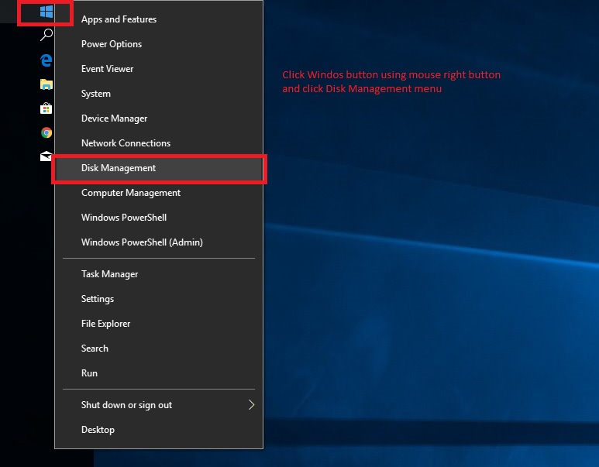
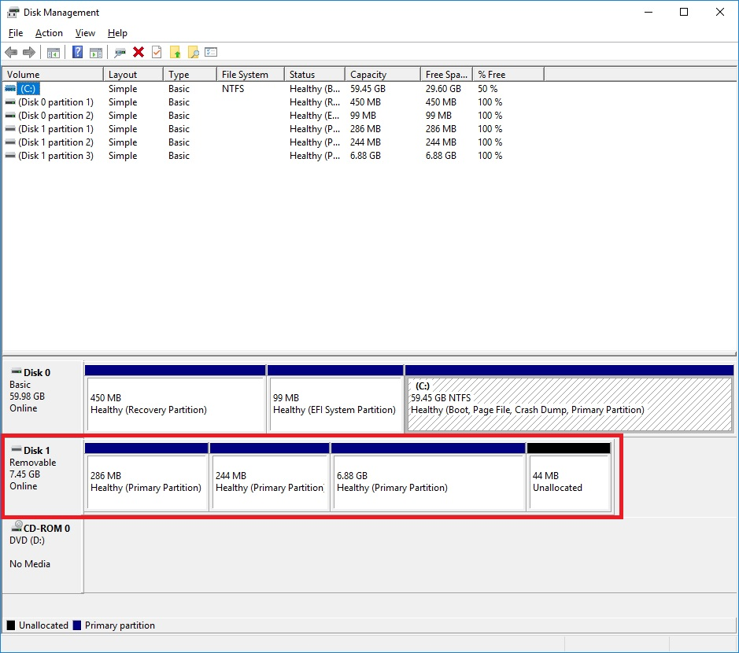
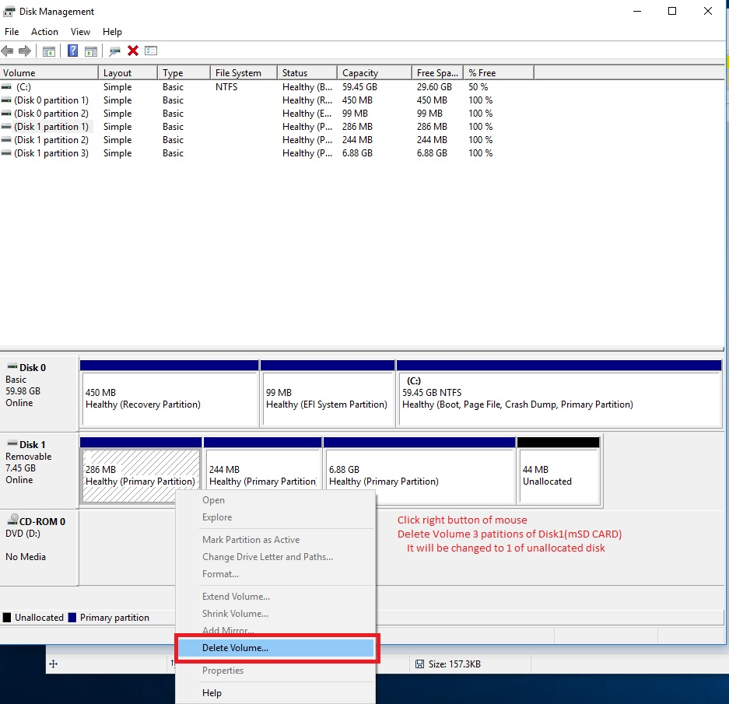
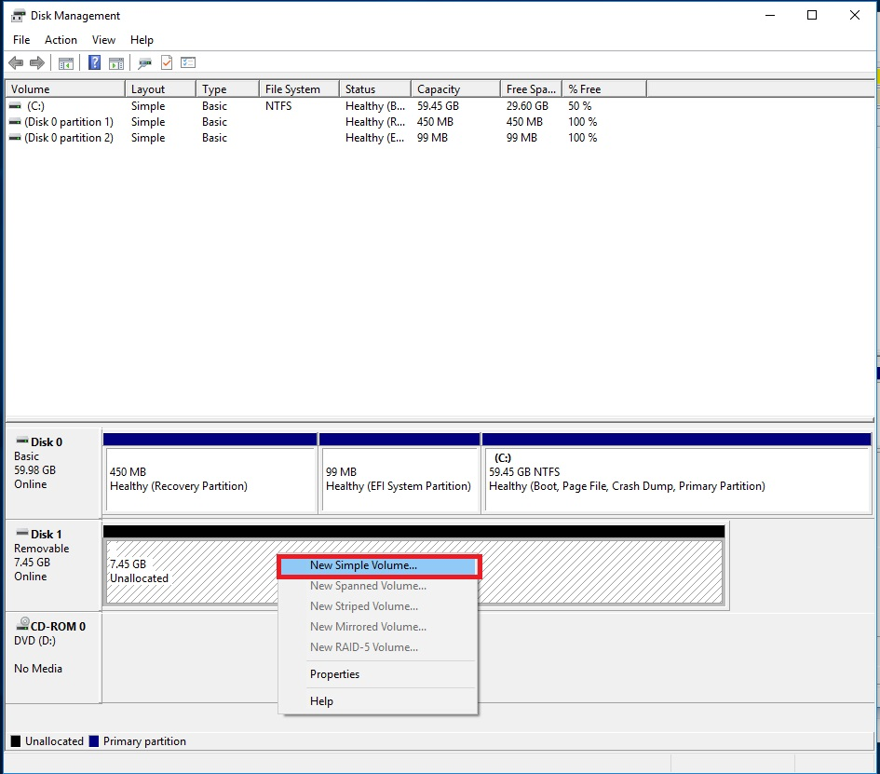
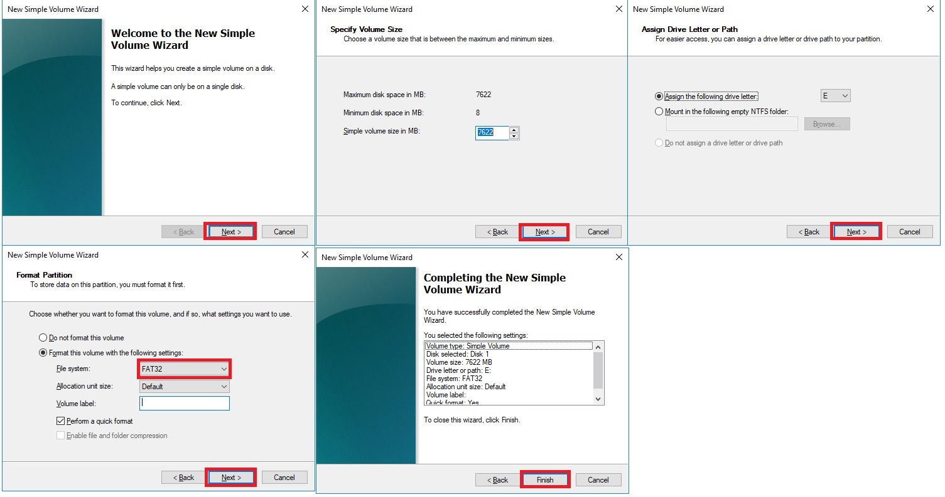
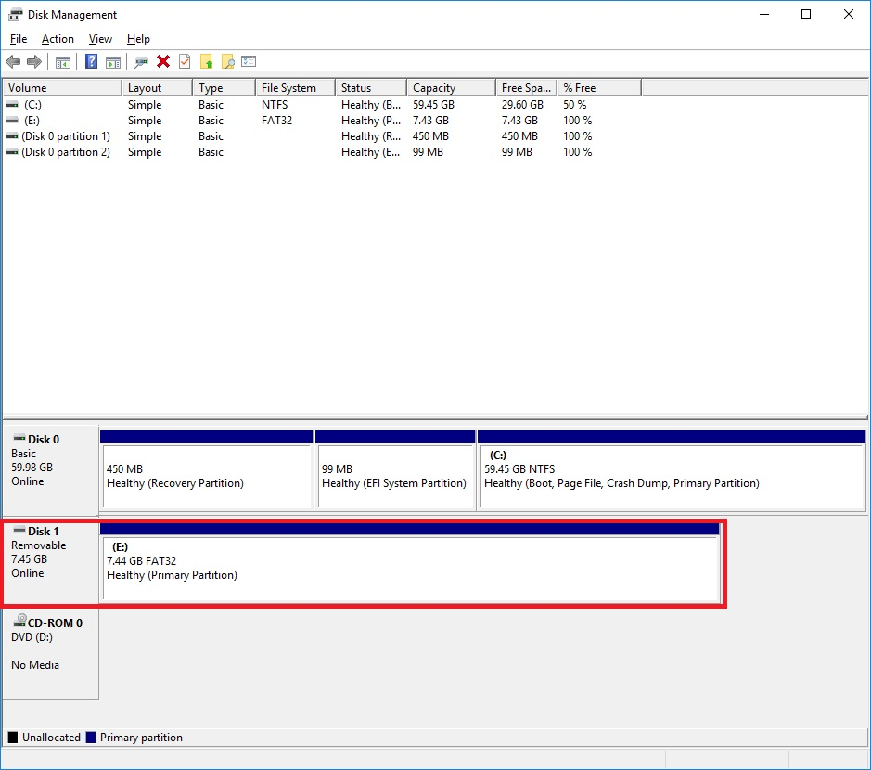

macOS

Preparation
- Download the new micro SD card image. Please note that the image file is quite big.
- Download the dd-utility from here or github. And install it.
- Eject the micro SD card from the rear panel of the sMS-200 and insert it into a PC's USB port using a micro SD card reader.

Start Restore
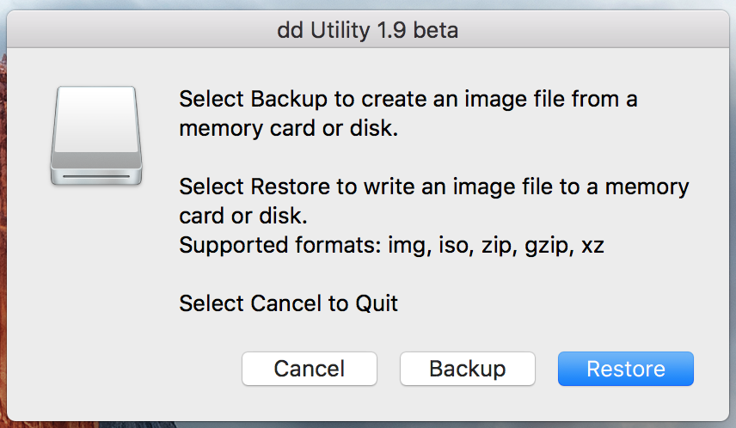
Click 'Restore' and select the downloaded .img file.
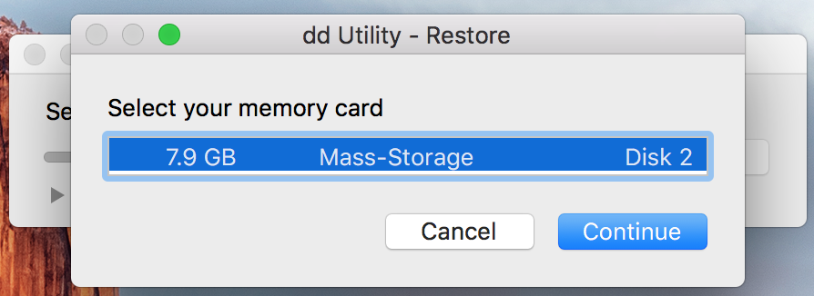
Select mSD card.
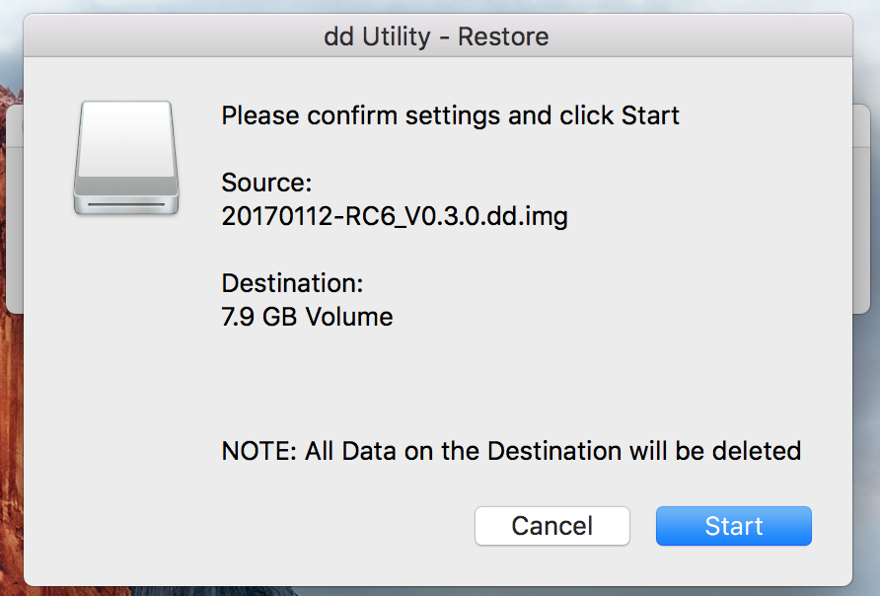
And start.
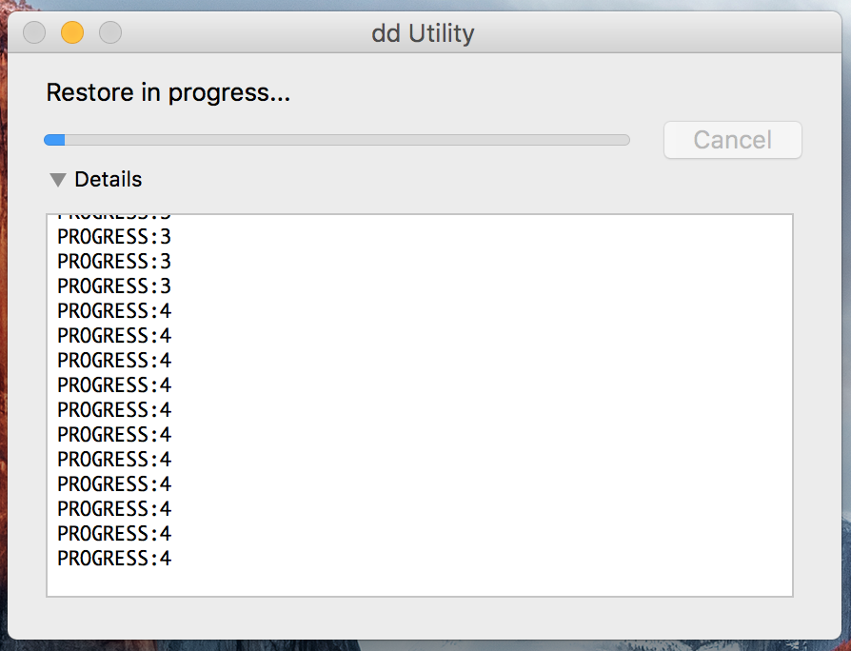
You can see the progress.

Finish
After finishing the process above, insert the mSD card to the mSD card slot of the sMS-200 or sMS-200ultra rear panel.
You can also use command-line by terminal instead of dd utility. Refer to here.

