This instruction is to install Eunhasu OS into the sMS-1000SQ.

Installing Eunhasu x86

Make the USB installation disk

Download the ISO image
- New Eunhasu x86 image

Download the Rufus program
- Download Rufus V3.4

Make the USB installation disk
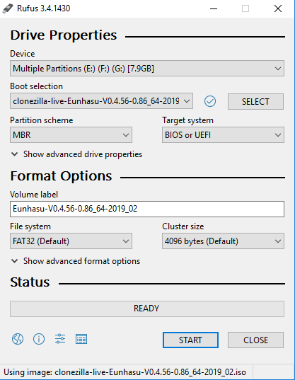
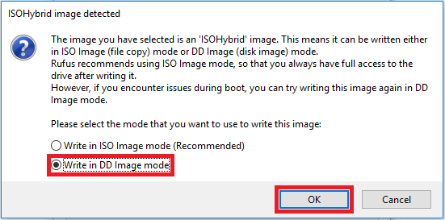

Install the Eunhasu OS

Precaution before installing Eunhasu OS
If the sMS-1000SQ has 2 internal storage disks installed, leave the disk for Eunhasu OS only and disconnect the other disk.

Boot the sMS-1000SQ
- Connect the Ordered List ItemEunhasu USB installation disk to the sMS-1000SQ's USB output.
- Connect an LCD monitor to the sMS-1000SQ with an HDMI cable.
- Connect a USB keyboard to the sMS-1000SQ and power on the device.
- Hit the F10 key to go to the booting disk selection screen. The F10 key should be hit at the same time as the unit is powered on.
- Select the inserted USB installation disk and start booting the device.

If you change the OS from the Vortexbox or Windows Edition to Eunhasu OS
- You will need to enable UEFI boot before installing Eunhasu OS newly.
- Please enter the BIOS setup by hitting F2 button once you power up the sMS-1000SQ.
- Go to the Boot menu, and check that UEFI boot is enabled. If it is disabled, please enable it.
- Go to Exit menu for Exit Saving Changes.
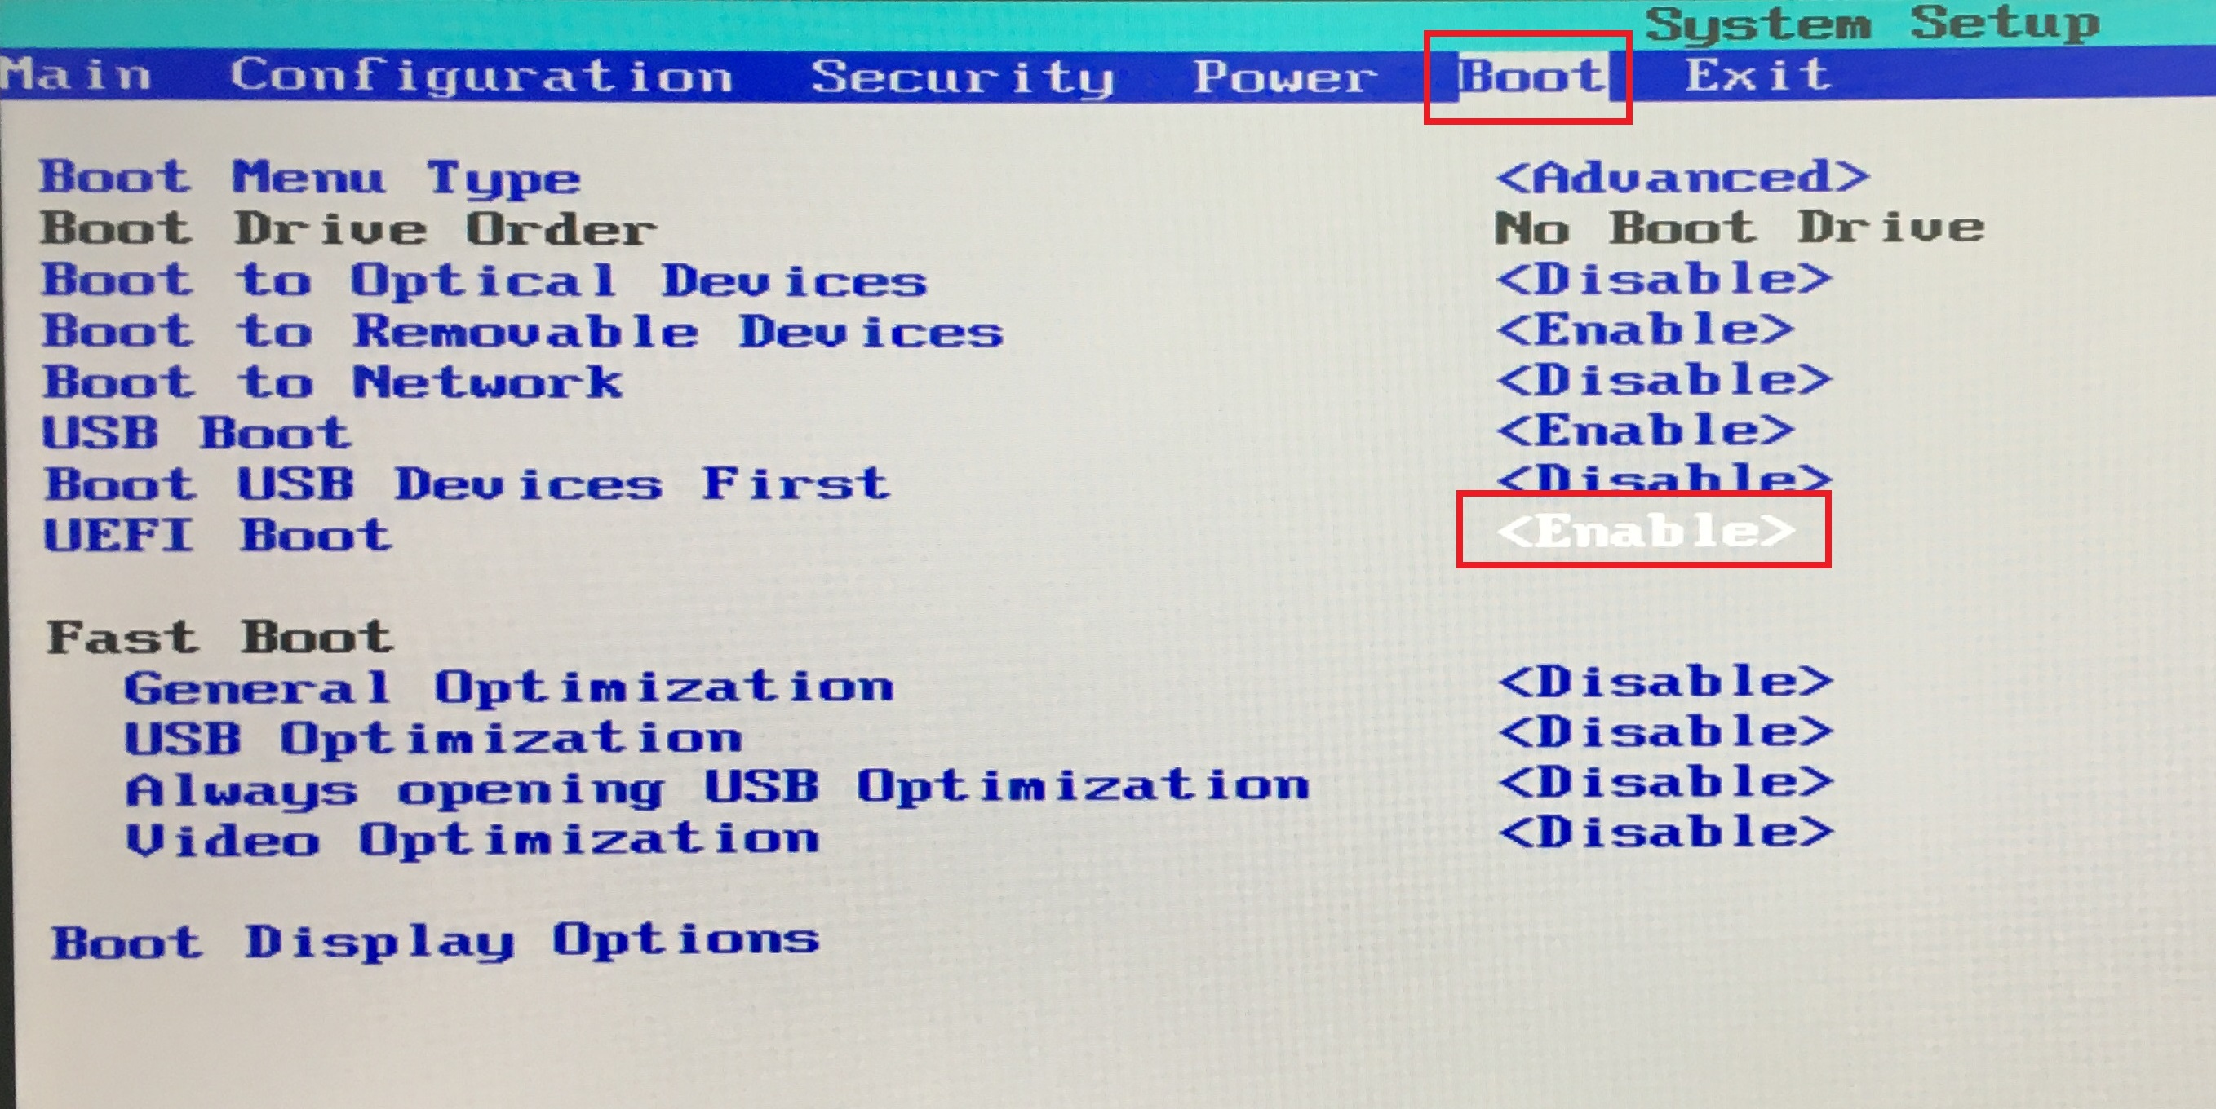
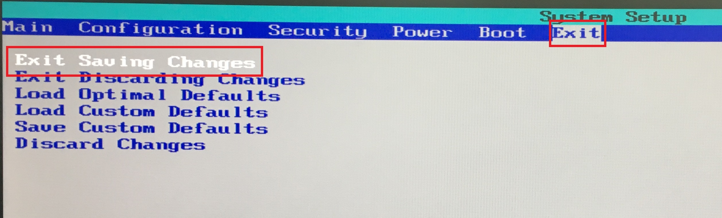

If the boot disk selection screen is not shown up
- If you are not able to see the boot disk selection screen when you hit the F10 button while turning on the power, follow the steps below to go to the Eunhasu setup screen.
Enter 'c' key on the screen (enter in 5 sec)
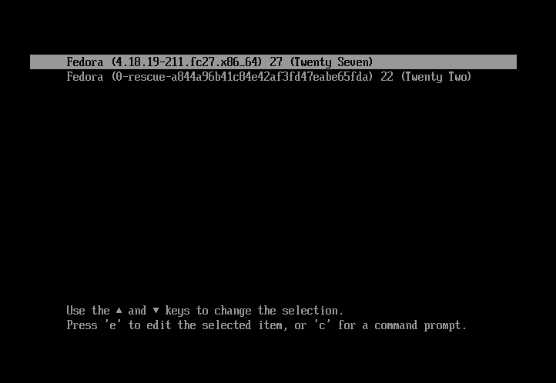
Enter the command below in order.
- grub> ls
- grub> set root=(xxx,msdos1)
- grub> set prefix=($root)/boot/grub
- grub> configfile /boot/grub/grub.cfg
when enteringxxx, you should check the (xxx,msdos1) disk like the image below and enter the same.
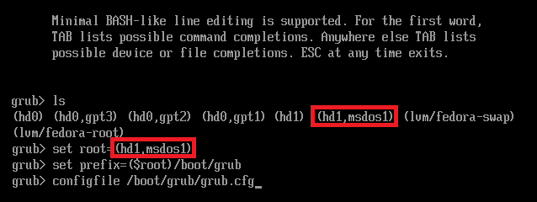

Proceed with the Eunhasu OS installation
Select the first menu on the screen, and keep continuing the boot.
- The displayed name may be different depending on the situation.
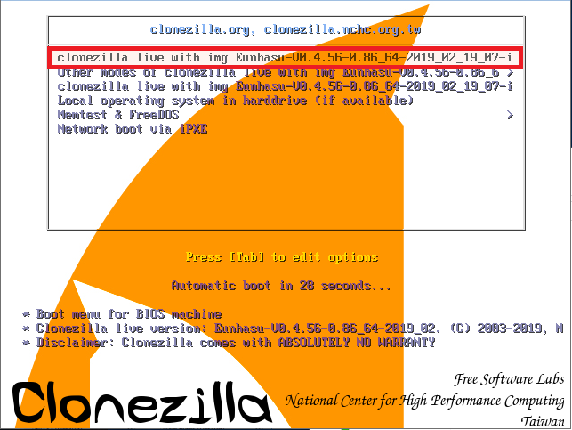
The disk check will be made while booting is processed, and the Eunhasu image will be installed into the sMS-1000SQ.
- Once the disk check is completed, press y key 2 times for the installation.
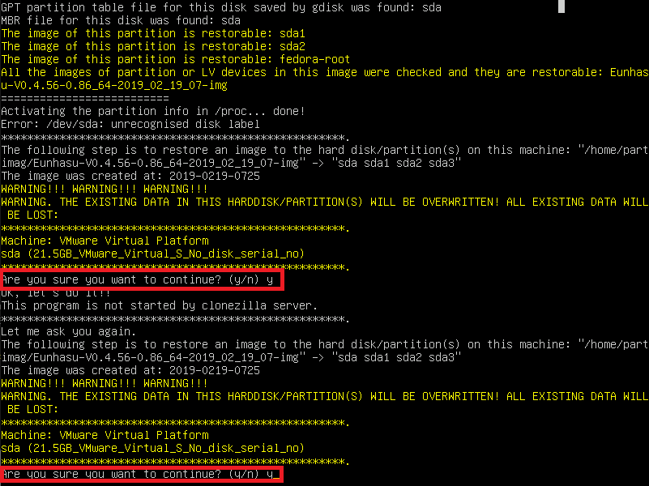
- The screenshot of the installation process
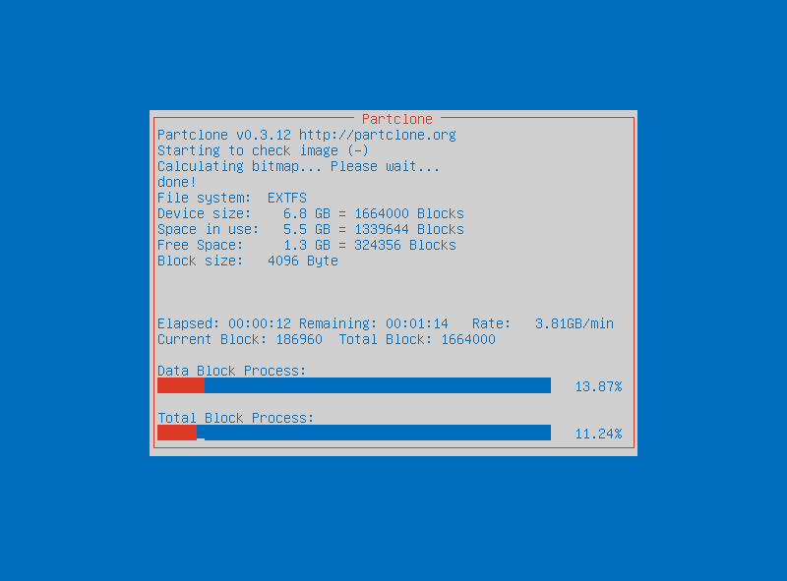
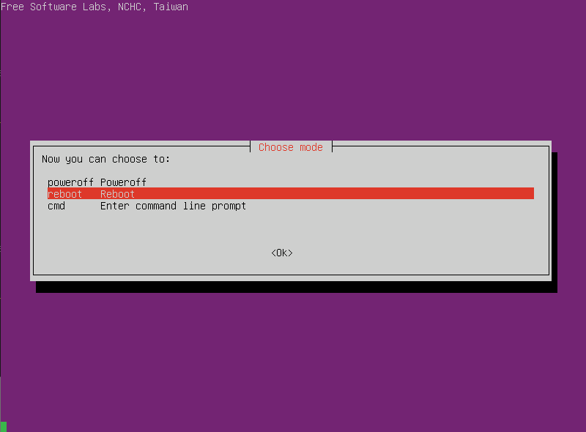
Once the installation is completed, reboot the device.

Increase the partition size for the storage
After re-booting the sMS-1000SQ Eunhasu, press the Ctrl+Alt+F2 buttons to go to the prompt mode.

Login
- ID : root
- PW : sotmaudio
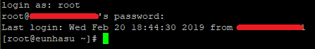

Increase the partition size
- Run the command line like the below.
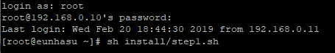
[root@localhost-live ~]# sh install/step1.sh
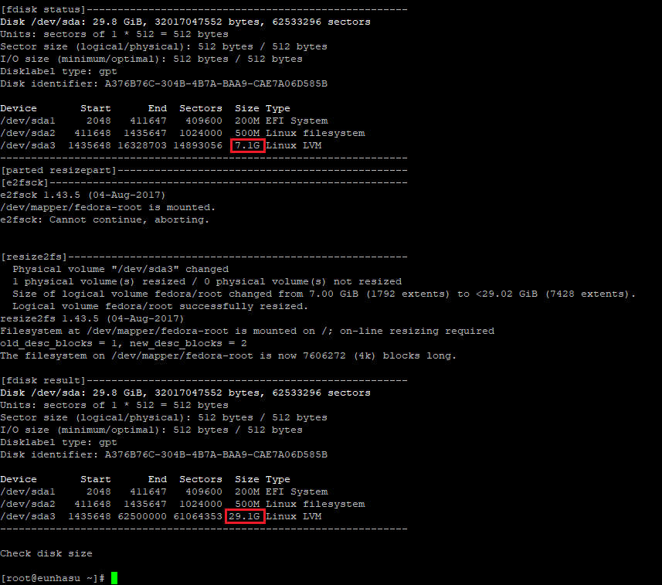

Mount an extra storage drive
Precaution, if you don't have an extra storage drive, please omit this process.
- Make sure you have powered off the sMS-1000SQ, and connect the extra storage drive.
- After powering up the sMS-1000SQ and completing the booting, log in using the ID an PW above with the same procedure as increase_the_partition_size_for_the_storage.

Run the mount script
Run the mount script.
[root@localhost-live ~]# sh install/eunhasu_check_hdd.sh
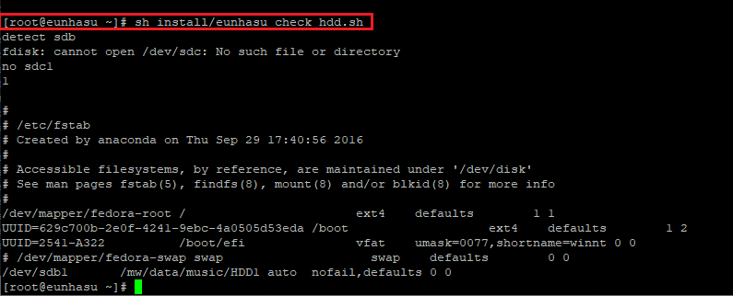

Download

Utilities
- Download Rufus V3.4

Eunhasu x86 image file
- [https://drive.google.com/drive/folders/1NGF1ikr2MtfF-FH8bQq5AHbxAWupaujV?usp=sharing|Eunhasu x86 V0.4.91]]

