Check serial number whether this instruction is needed or not.

Hardware

Disassemble the front case
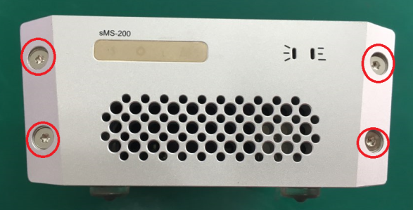
Unscrew the 4 Torx screws as shown.

Disassemble the LED board
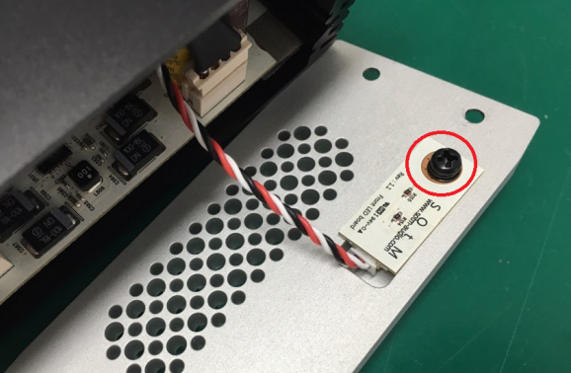
Unscrew the black screw and separate the LED board from the front case.

Disassemble the rear case
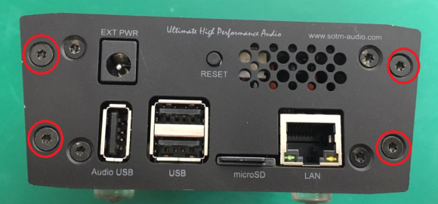
Unscrew the 4 Torx screws as shown.

Remove 'C670' Chip Capacitor
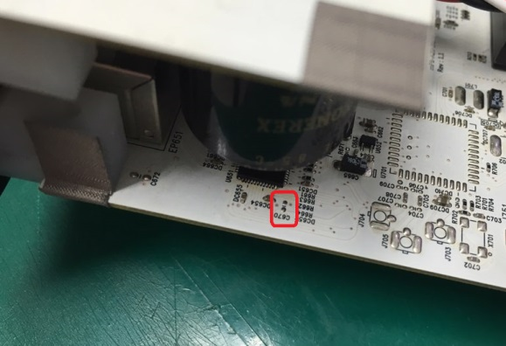
Pull out the rear case very carefully to disassemble the main board from the body case. Remove 'C670' with a soldering iron. If necessary, the power board can be disassembled.

Assemble sMS-200 cases
Repeat to assemble sMS-200 cases in the reverse order.

Software
To change the micro SD card image, please refer to 'burn sdcard image' page.

Windows

Preparation
- Download the new micro SD card image in the link below. Please be noted the image file is quite big (7.4GB BIN file) 20170112-RC6_V0.3.0.bin
- Download the imageUSB utility and unzip.
- Take out the micro SD card from the rear case of sMS-200 and insert to the USB port by using the micro SD card reader.

Run imageUSB
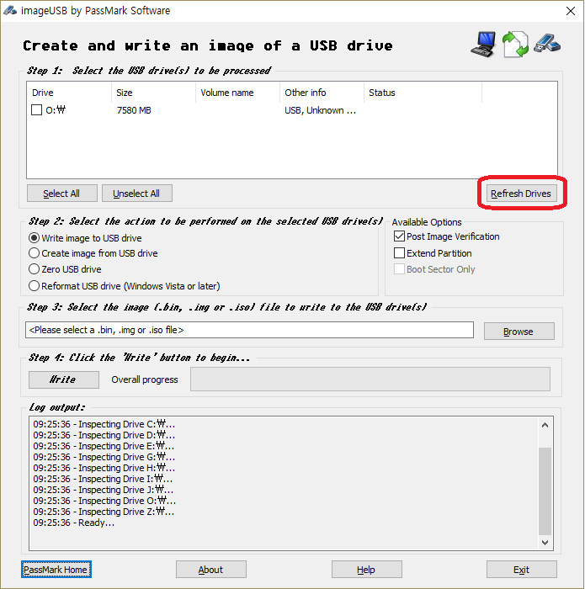
Run imageUSB. The connected USB device will be shown up. If the connected USB device is not shown, click 'Refresh Drives'.

Select an USB device
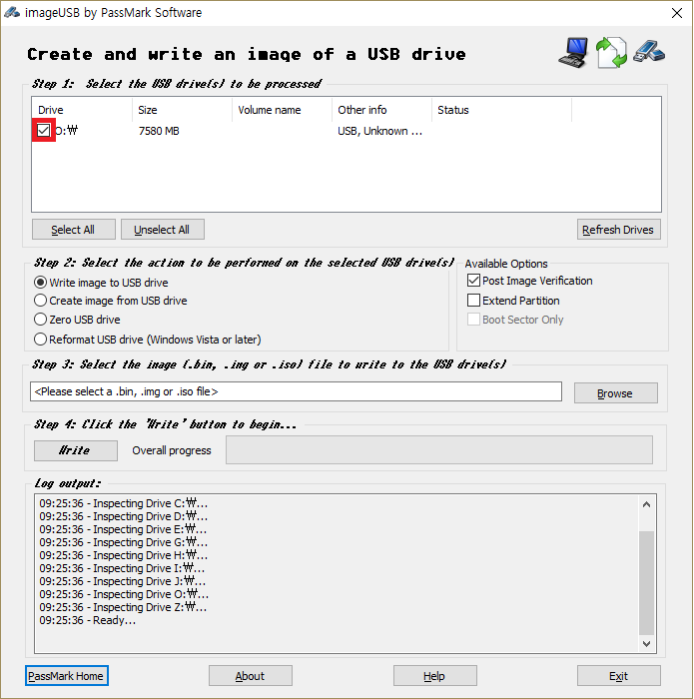
Select an USB device to write the new image file.

Select the new image file
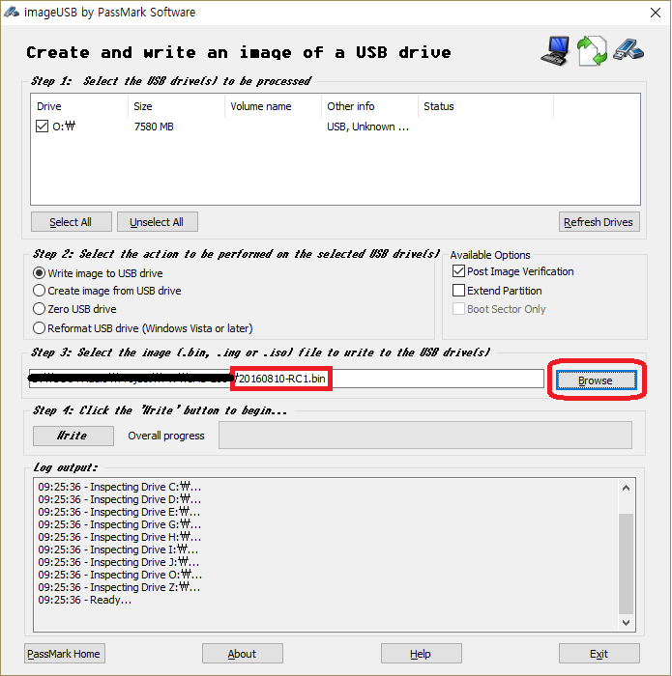
Click 'Browse' button and select the downloaded image file.

Write the new image
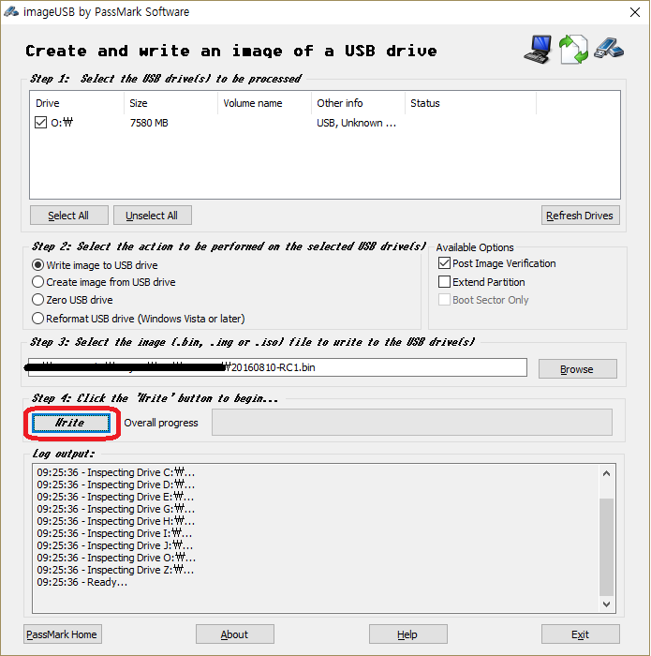
Click 'Write' button to write the new image file to the micro SD card.

Finish
- Insert the micro SD card to the rear panel of sMS-200 again.
- Power on sMS-200, and apply the latest software upgrade in Eunhasu animated GUI settings.

macOS

Preparation
- Download the new micro SD card image in the link below. Please be noted the image file is quite big (7.4GB img file) 20170112-RC6_V0.3.0.dd.img
- Download dd-utility from here or github. And install it.
- Eject the micro SD card from the rear case of sMS-200 and insert to PC USB port by using the micro SD card reader.

Start Restore
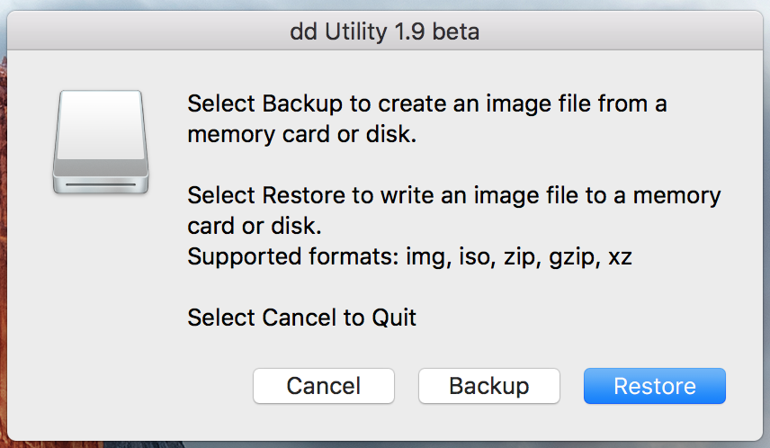
Click 'Restore' and select downloaded .img file.
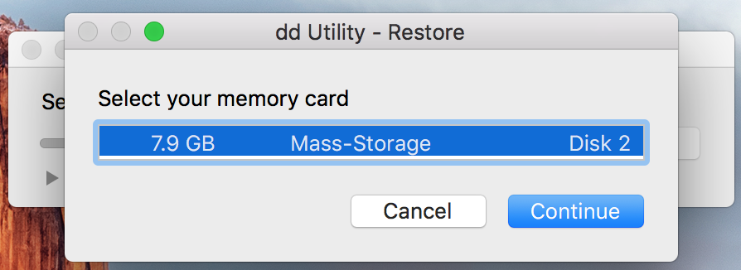
Select SD card.
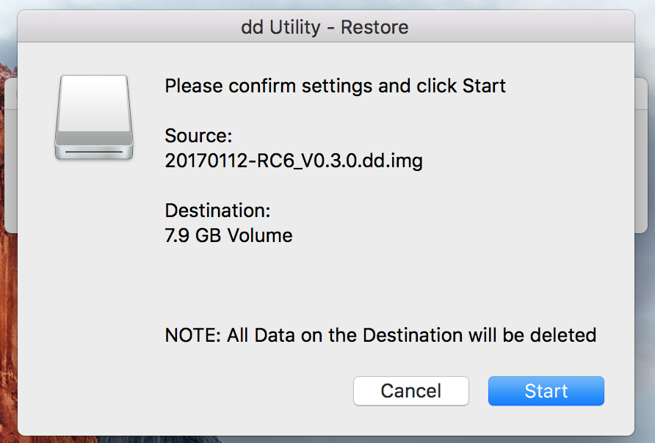
And start.
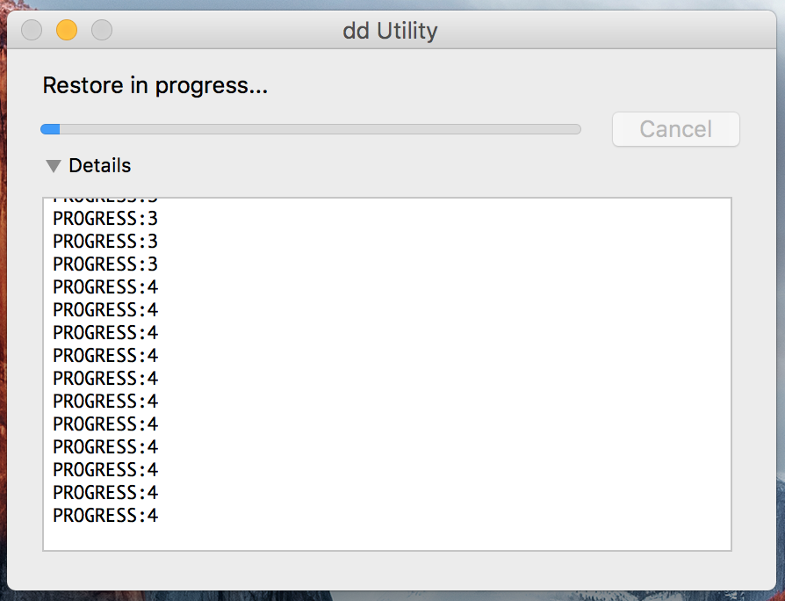
You can see progress.
After done, insert the SD card to sMS-200 rear.
You can also use command-line by terminal instead of dd utility. Refer to here.

