Download
Download the dX-USB HD windows driver file from http://www.sotm-audio.com/sotmwp/english/portfolio-item/dx-usb-hd/
Click here to see the installation video, https://drive.google.com/file/d/1lD6Z-KeX8YV5poR2zslvm2yGrVjRH_0V/view?usp=sharing

Install
Unzip the downloaded file and run setup.exe
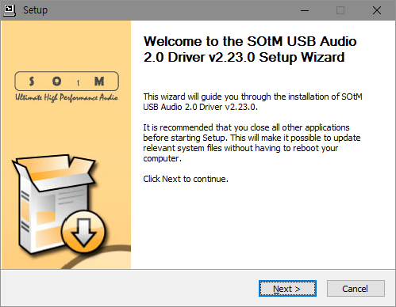
Please click the “Next” button to proceed to the next steps
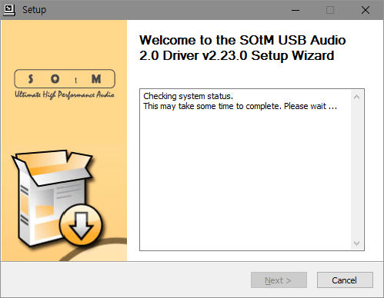
Checking system status. Please connect the unit to a PC by USB cable and make sure the unit is operational.
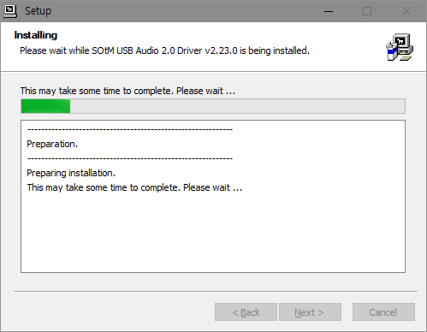
Installation is started. Press the “Next” button to go to the final stage once the setup is completed.
Caution : This depends on USB audio class 2.0 driver version, the unit should be connected to PC by USB cable, and install the driver while the unit is in operation.
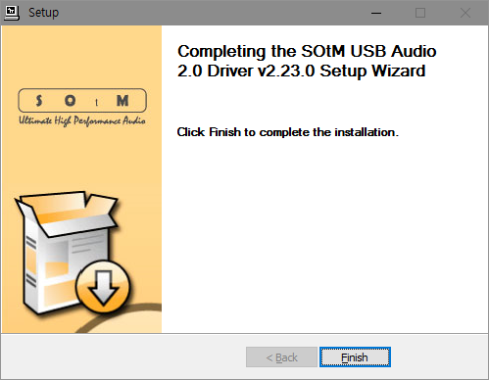
To complete the installation of the driver, please click the “Finish” button.

Control Panel
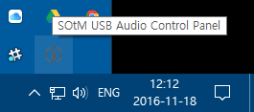
SOtM USB Audio Control Panel’s icon will appear on the task bar once the installation has finished.
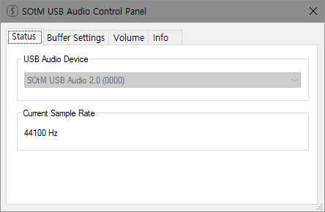
Please double click the Control Panel icon and then the driver information will appear, you can check the driver version information and etc.
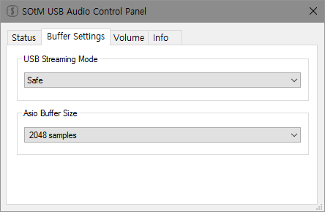
If you select “Buffer Settings”, you can adjust the streaming Buffer Size and ASIO Buffer Size.
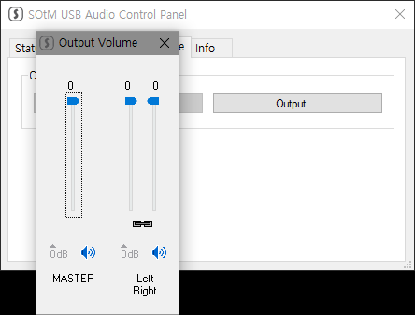
The Volume Control will be shown as the below image, and you can control the maximum(0dB) and minimum(Mute) values by the buttons or the slide bars.

Upgrade Firmware
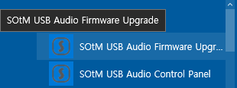
Start the firmware upgrade application.
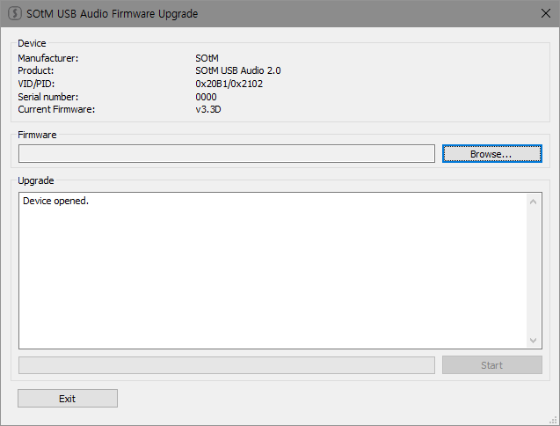
Firmware upgrade application window.
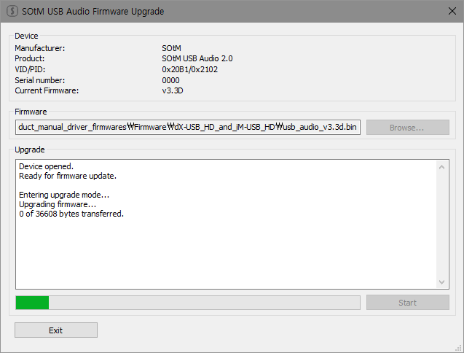
Select the firmware file and start the upgrade.
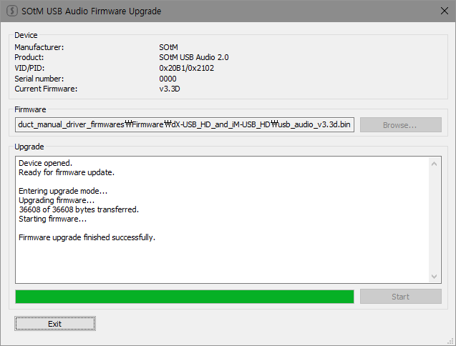
Finish upgrade.
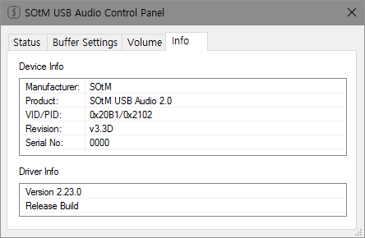
You can see the result of the upgrade in the control panel.

