sDP-1000 Battery Replacement Instruction
CAUTION
- If circumstances allow, ask replacement to distributor or retail shop.
- Be careful not to overtighten screws.
- Please recycle your used batteries that have explosion risk
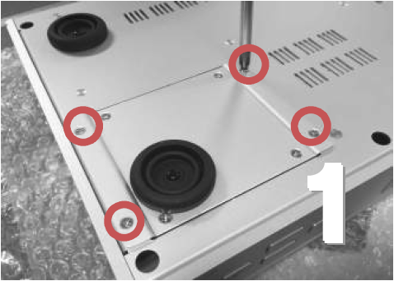
Remove the outer four Phillips screws carefully
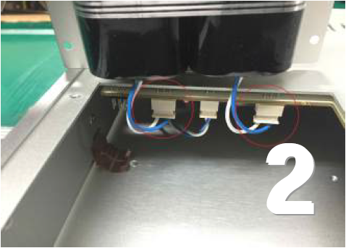
Remove the outer two connectors by pulling down. Leave the center connector alone.
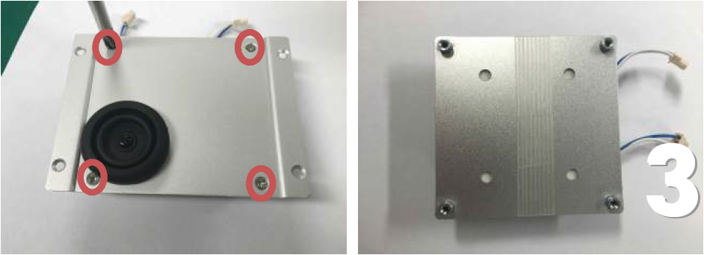
- Unscrew the four remaining screws on the battery holder plate.
- Unwrap the tape the nylon reinforced tape from the batteries/back-plate.
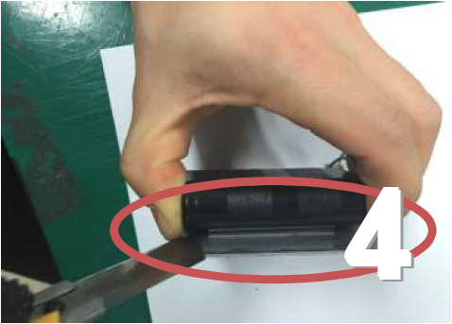
Carefully pry the battery packs off the back plate by using tools such as straight razor
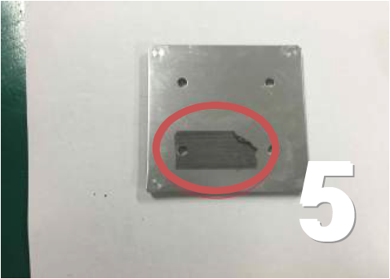
Remove residual tape on the back-plate.
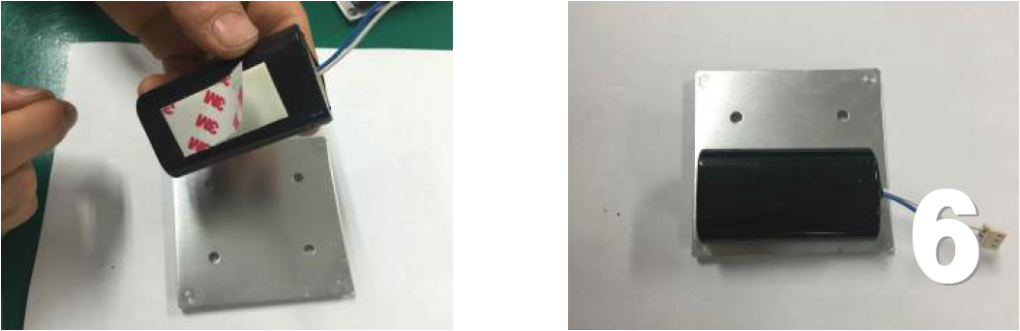
Remove backing on the two way tape from the new battery; center carefully on the two holes and make a little space between two batteries.
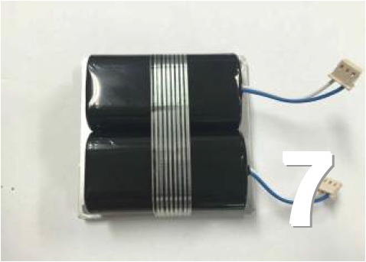
Wrap batteries and back-plate with the provided nylon reinforced tape.
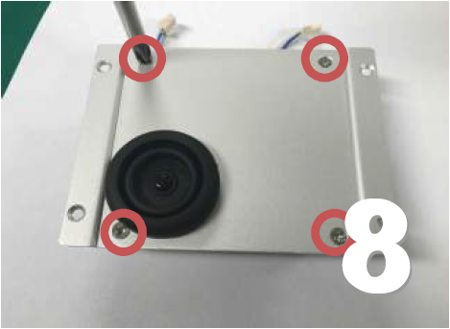
Screw the back-plate with batteries to the battery holder plate.
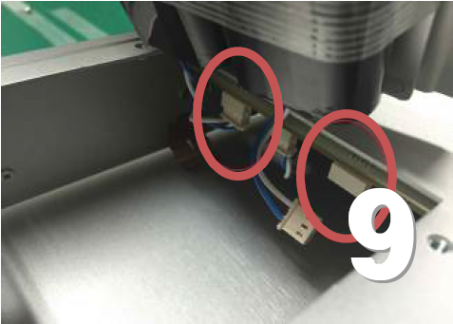
Holding the new battery pack at an angle above the opening, plug the outer (battery) terminals in.
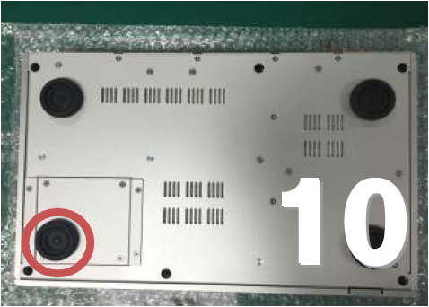
Screw the battery holder plate (outer four) screws in place, making sure the foot is positioned in the lower, outside corner.

