Requirement
- sMS-200 V0.3.0 above or sMS-1000SQ Eunhasu V0.3.0 above
- Wifi dongle
  - RTL8812AU chipset

Simple Instruction
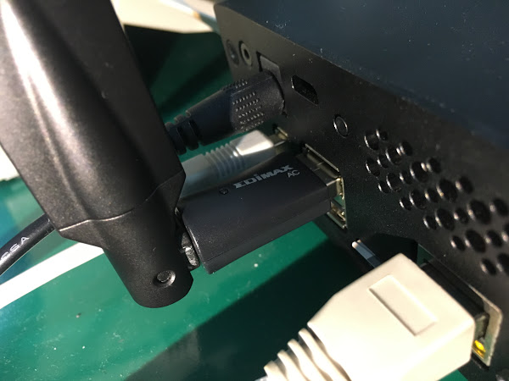
Connect Wifi USB dongle into USB port. To setup Wifi feature on Eunhasu, the wired LAN should be connected.
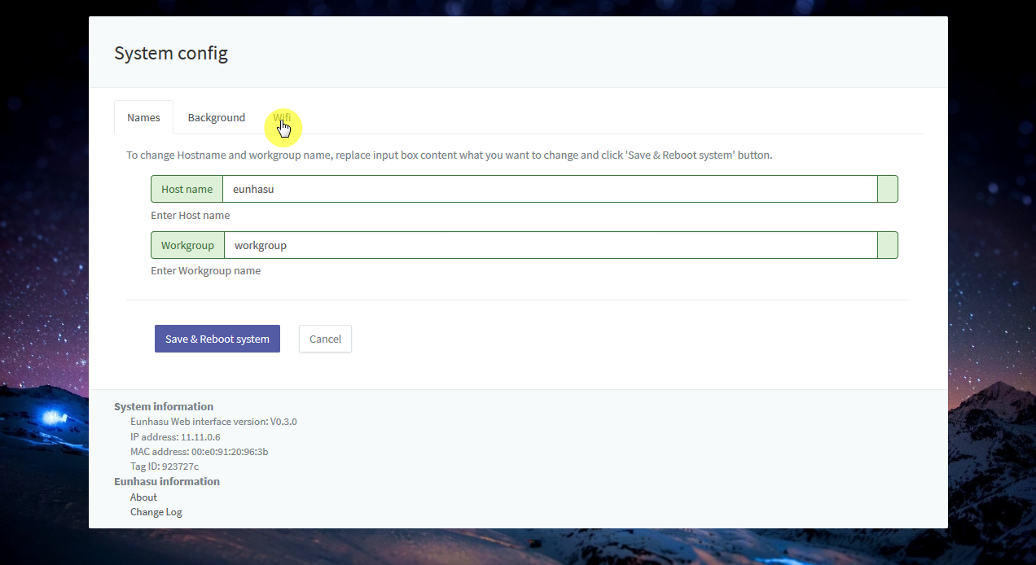
Click 'Wifi' tab in System config page.
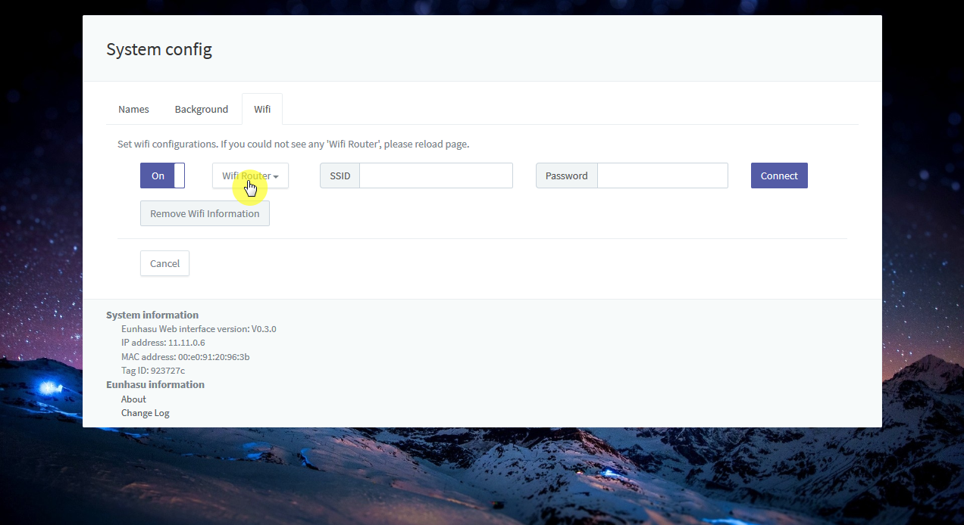
Click 'Wifi Router' button to show Wireless Access Point and it will take a few minutes to be detected the AP.
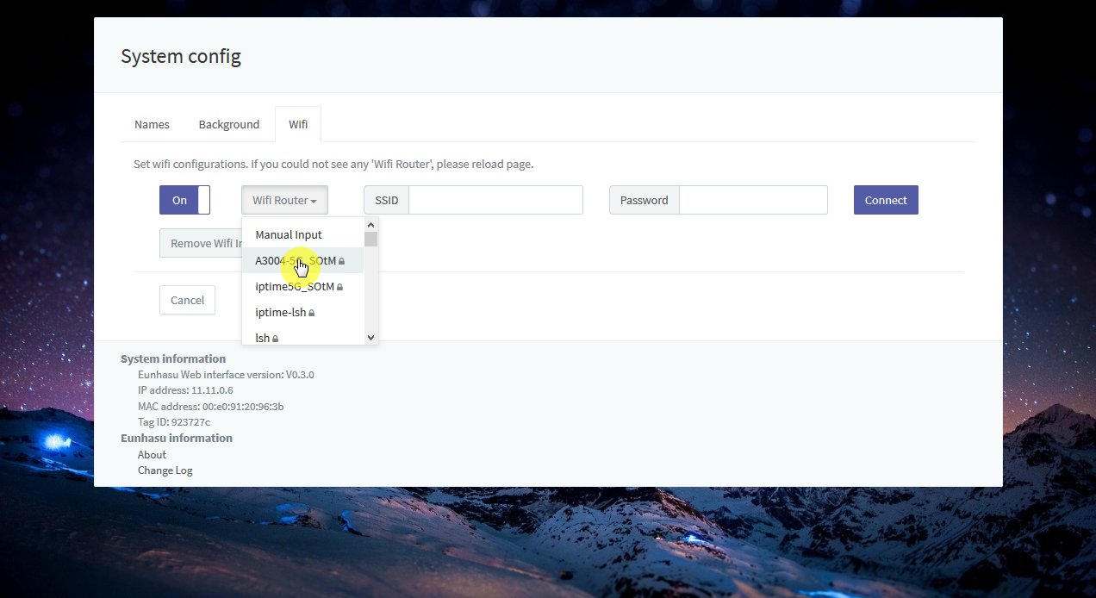
Select AP what you want.
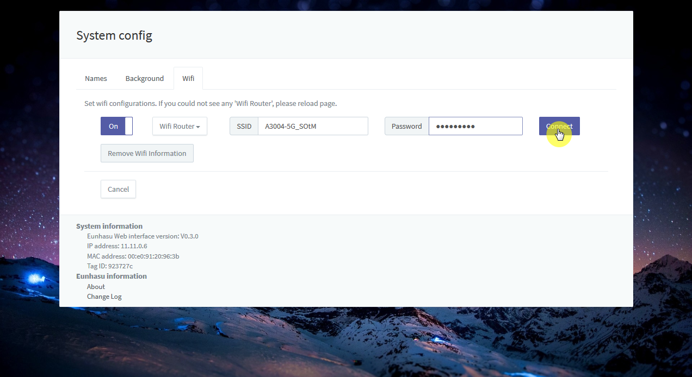
Enter a password or secret if required.
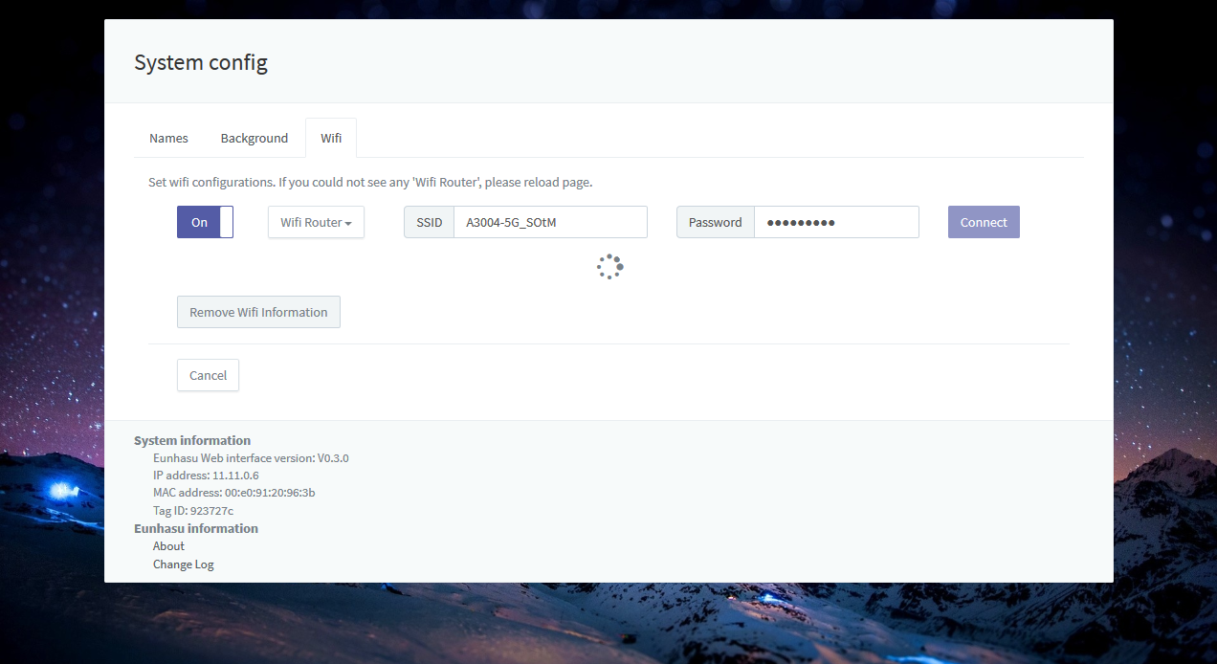
Wait till the progress will be done.
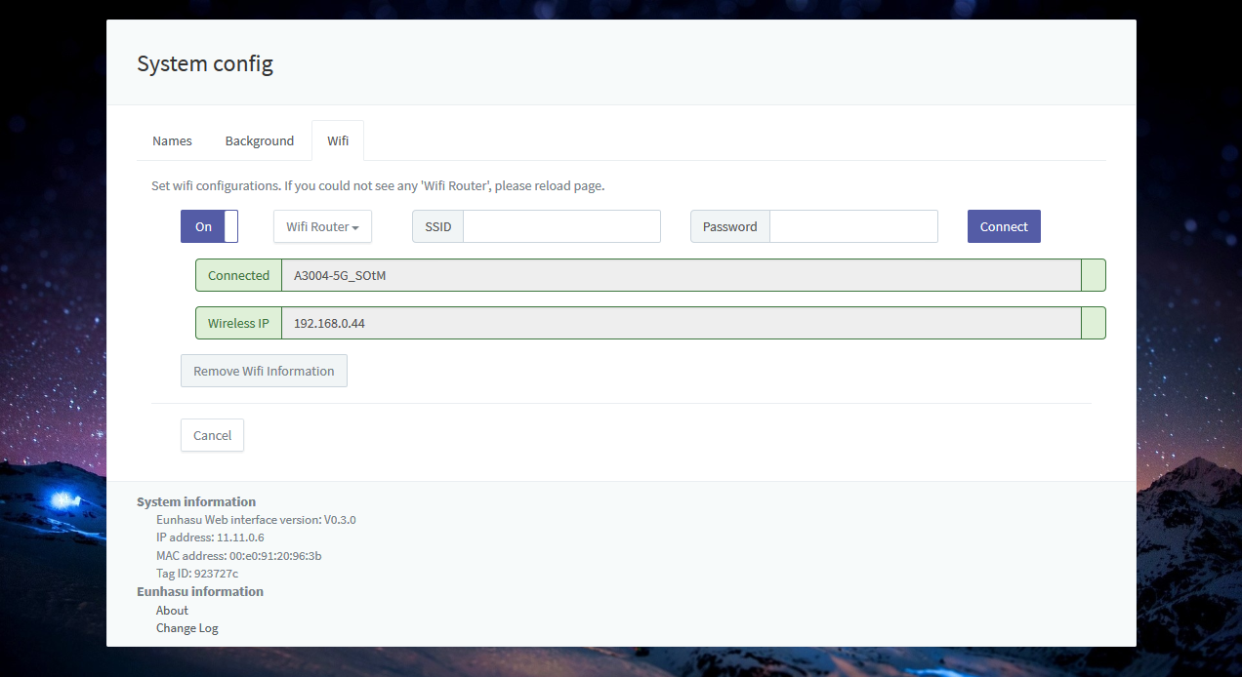
After connecting successfully, you can see IP address like the screen shot below.
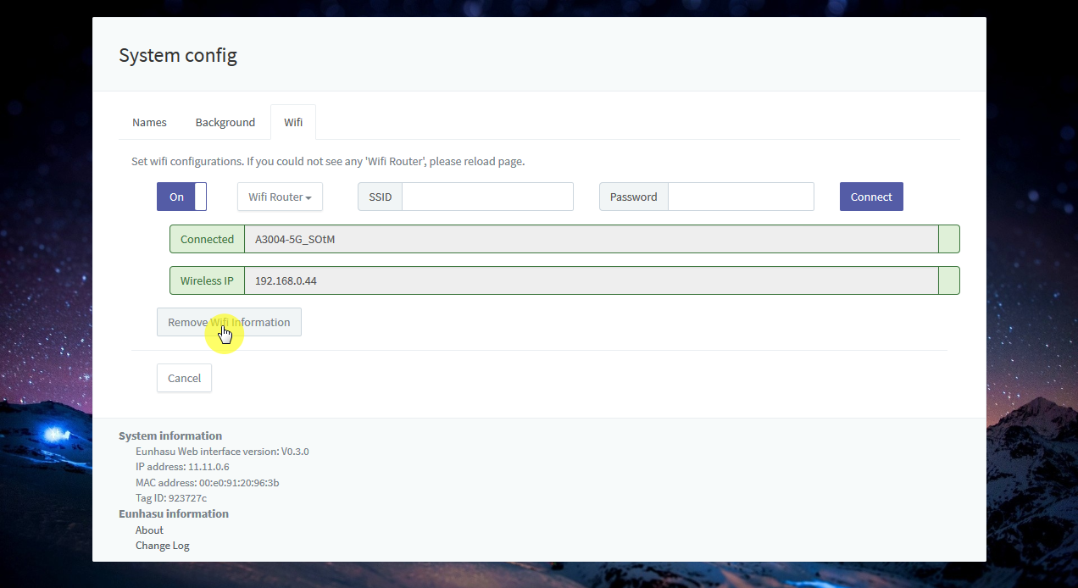
'Remove Wifi Information' button will remove all stored information include the name and password.
- Eunhasu version >= V0.3.0 required.
- There might be connection error if you use wired and wireless network at the same time.
- Network speed could be degraded depends on wireless network status.
- After wireless connected, use IP address to connect

Last Updated:

