MinimServer
MinimServer is one of the best UPnP Audio Server. MinimServer collects user's musics intelligently and operates with DLNA control point such as Bubble UPNP. You can search and playback your music files more convenient.
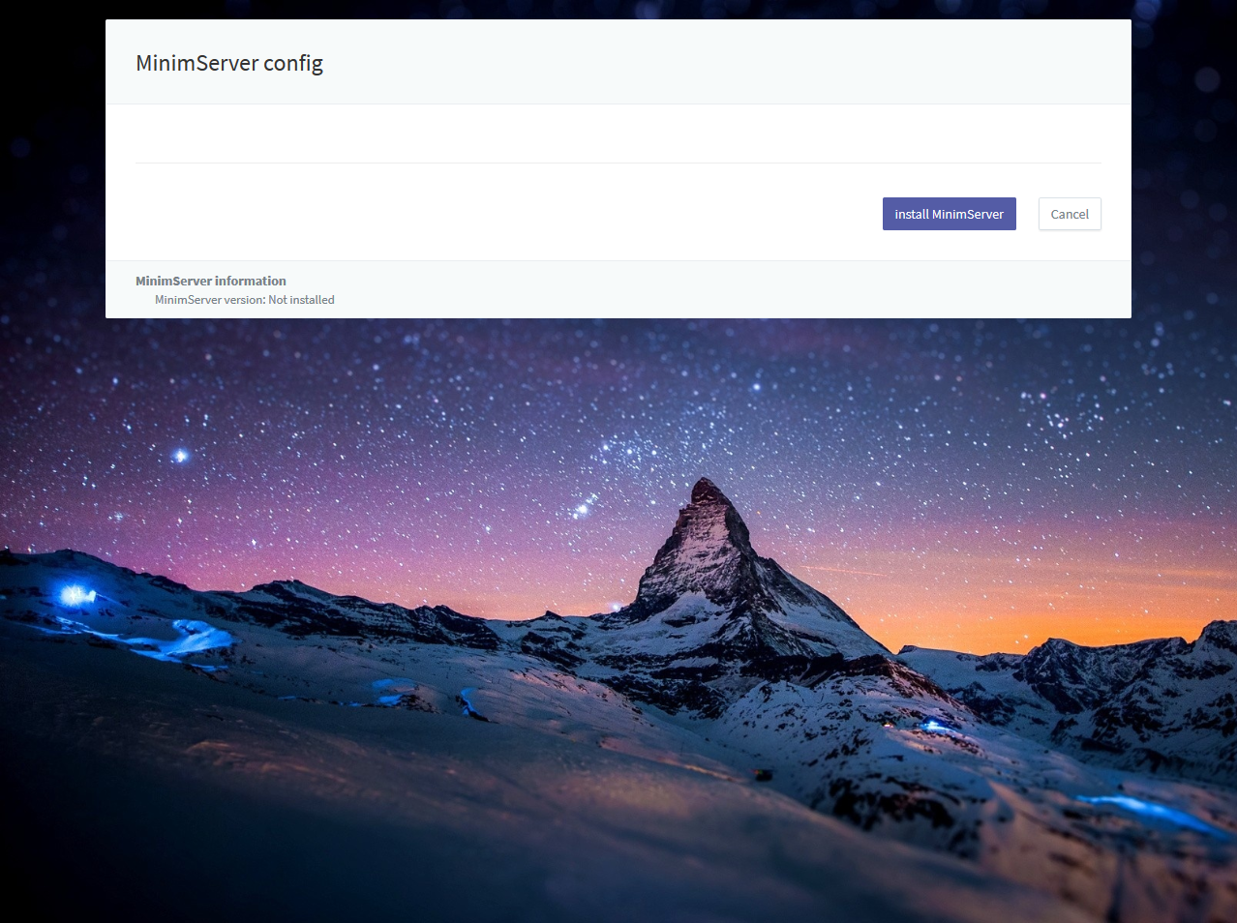
MinimServer should be installed by user. Installation is available in MinimServer config page.
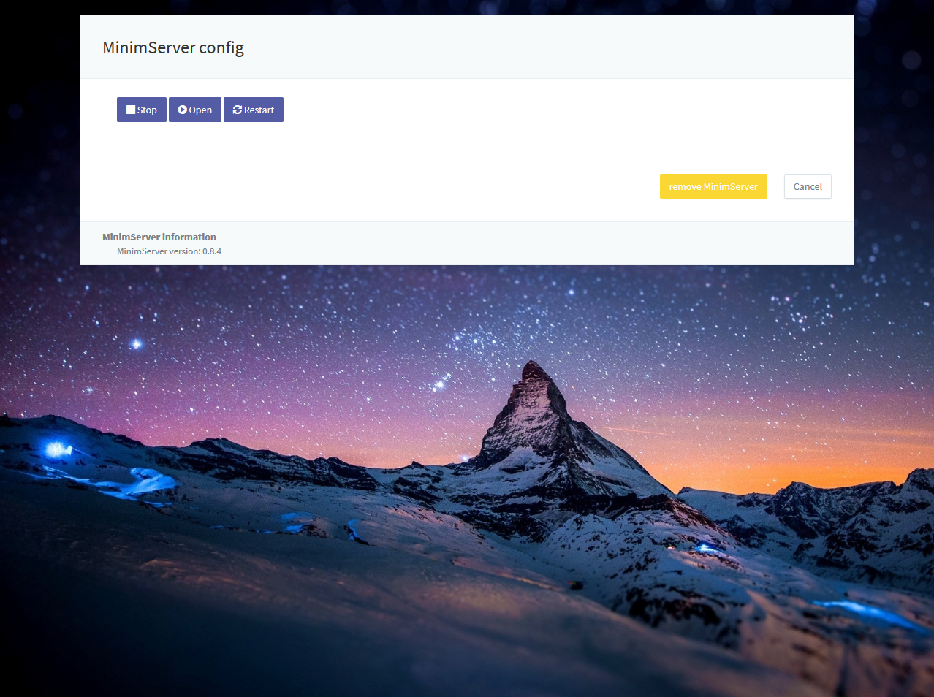
MinimServer can be controlled in MinimServer config such as start, open, stop or restart after installation done.
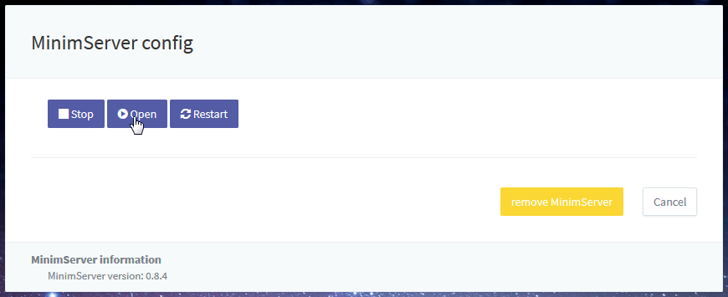
Content directory of MinimServer setting has to be set in MinimServer config page which could be open after start MinimServer.
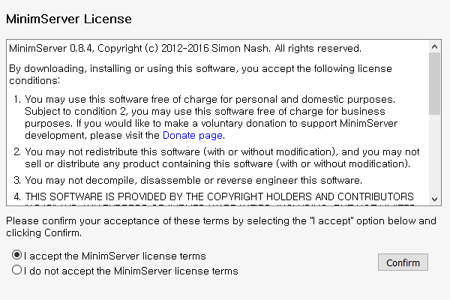
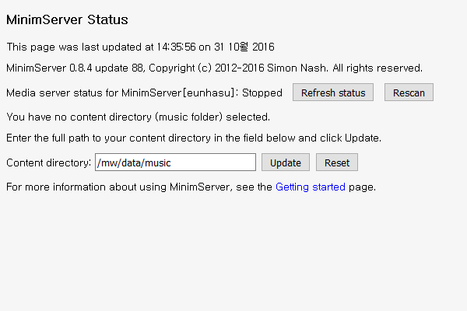
First to use, you have to accept MinimServer license terms.
- Content directory shoule be /mw/data/music to collect musics in Eunhasu system.
- If /mw/data/music space were 100% full, main system would be abnormal states and not be operated normally.

Last Updated:

