MPD / DLNA renderer
MPD is a high performance music playback service that can play music files on a USB storage device or network share folder. Eunhasu has only DLNA audio renderer not including other DLNA stacks. You can use Eunhasu with a DLNA server. However, sMS-1000SQ Eunhasu product has a DLNA server feature which is MinimServer. You could use 'MPD / DLNA renderer' with MinimServer if you have sMS-1000SQ Eunhasu.
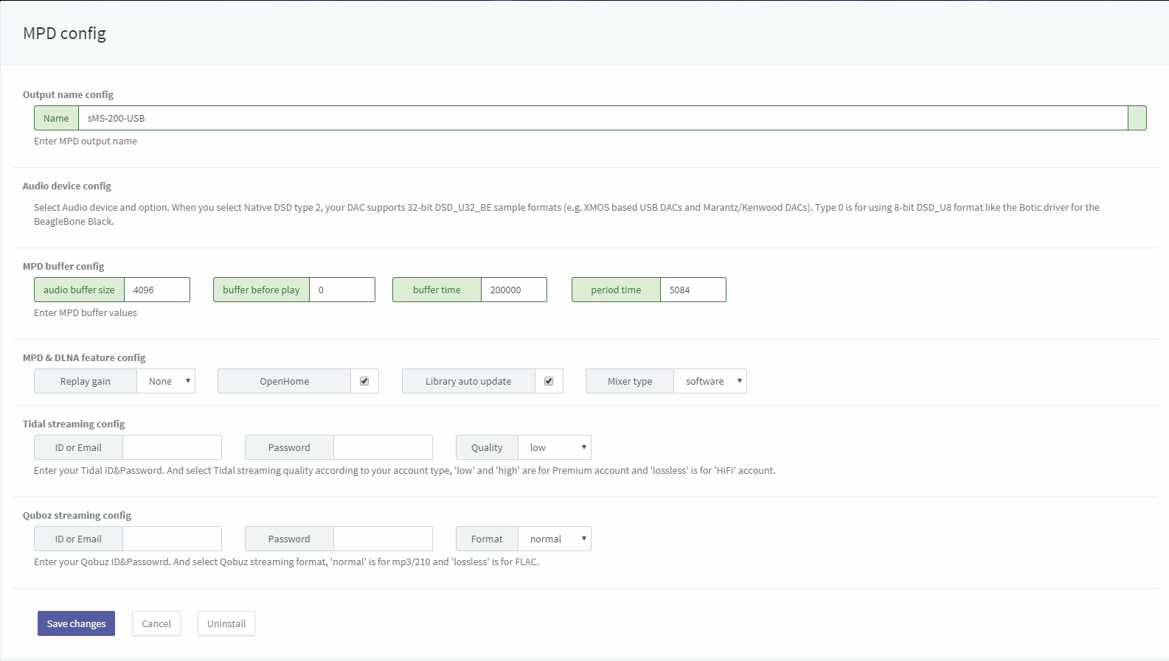full
- Name: A name of Eunhasu's MPD & DLNA is appearing on MPD client app and DLNA control point. You can change the name if you need.
- Audio device config: Select a radio button of USB DAC which is going to use and click 'Save changes' to use the USB DAC.
- DOP enable: Check for using DOP function while playing DSD music file.
- Native DSD type 0: To use 8-bit DSD_U8 format DAC. (e.g. BeagleBone Black using Botic driver)
- Native DSD type 2: To use 32-bit DSD_U32_BE format DAC. (e.g. XMOS-based USB DACs or Marantz/Kenwood DAC)
- Replay gain: Choose Replay gain among None, Album or Track.
- OpenHome DLNA Renderer: Check for using OpenHome DLNA Renderer feature.
- Library auto update: Check for auto-scanning and updating the library.
- MPD Buffer config: Adjust the buffer value according to your environment.(Like network status, hardware specification.)
  - Audio buffer size: Specify the size of the audio buffer in Kbytes.
  - Buffer before play: Specify the amount of audio buffer that must be filled before playing music file. Increase the value if the song is cut when moving to the next music file. Only numbers between 0 and 100 can be entered.
  - Buffer time: Set the buffer length of the music file data to be sent to the audio device in microseconds.
  - Period time: Set the transmission interval of the music file data to be transmitted to the audio device in microseconds.
Details of each section on Buffer config can be confirmed at the following URL. https://linux.die.net/man/5/mpd.conf
- Tidal streaming config: This is for users who use Tidal streaming with mpd / dlna feature. Enter your Tidal account information to the ID and Password fields. In Quality field, set the proper value according to your Tidal account. Select low / high quality for Tidal premium account, or Lossless for HIFI account.
- Qobuz streaming config: This is for users who use Qobuz streaming with mpd / dlna feature. Enter your Qobuz account information to the ID and Password fields. In Format field, set the proper value according to your Qobuz account. Select normal for playing mp3 music file, and lossless for playing FLAC music file.
Native DSD feature is available from Eunhasu V0.3.2.
A user's feedback on MPD buffer config. He reported the issue that when playing some flac files in sampling rates higher than 48kHz with NuForce DAC80, there were continuous drop-outs hearable, but after changing various settings, all worked fine back. The following setting values were effective for his environment. Audio Buffer Size: 65536 Buffer Before Play: 100 Buffer Time: 100000 Period Time: 32
He also added a comment that Period time affact to the result most.

MPD clients
- MPDroid: https://play.google.com/store/apps/details?id=com.namelessdev.mpdroid
- M.A.L.P. - MPD Client: https://play.google.com/store/apps/details?id=org.gateshipone.malp
- MPod: https://itunes.apple.com/kr/app/mpod/id285063020?mt=8 out of dated
- MPDluxe: https://itunes.apple.com/us/app/mpdluxe/id991758069?mt=8
- Gnome Music Player Client: https://gmpclient.org/installation
- Chimney: https://www.microsoft.com/en-us/store/p/chimney/9wzdncrfj6jx
Reference: http://mpd.wikia.com/wiki/Clients

how to connect and access NAS in sMS-200
How to connect NAS to Squeezelite or MPD/DLNA on sMS-200

Last Updated:

