How to update the sMB-Q370 Bios version
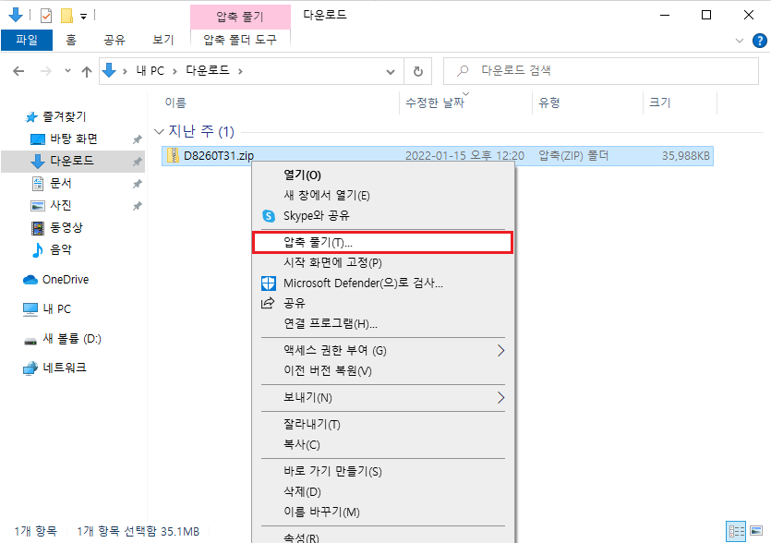
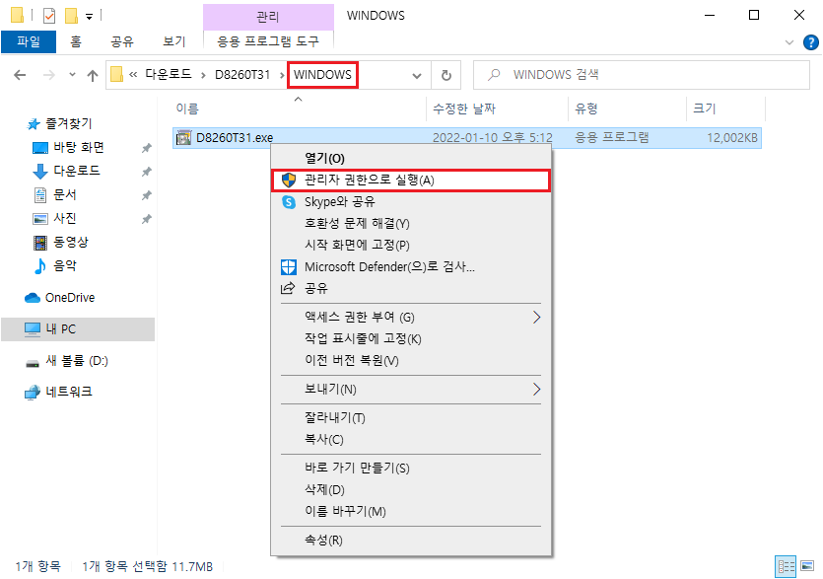
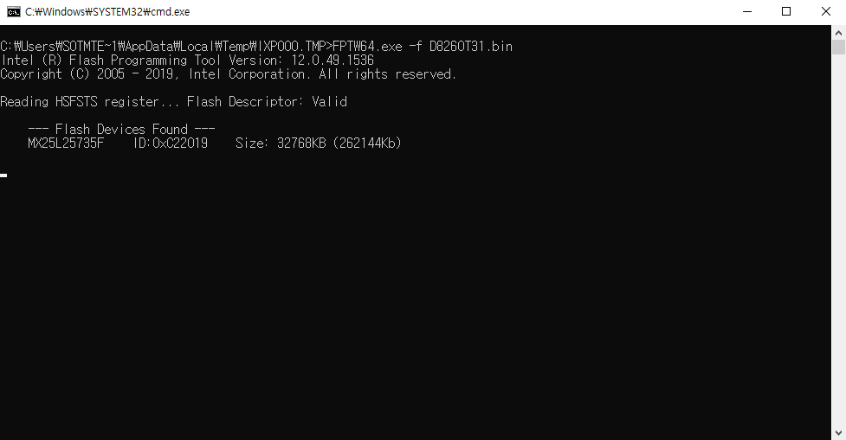
1. Boot up with WindowsOS. Download D8260T31.zip file and unzip properly. 2. Run D8260T31.exe as administrator. 3. Wait till the update would be completed, then the windows will be closed.

BIOS download file
- D8260T31.zip

