sMS-200
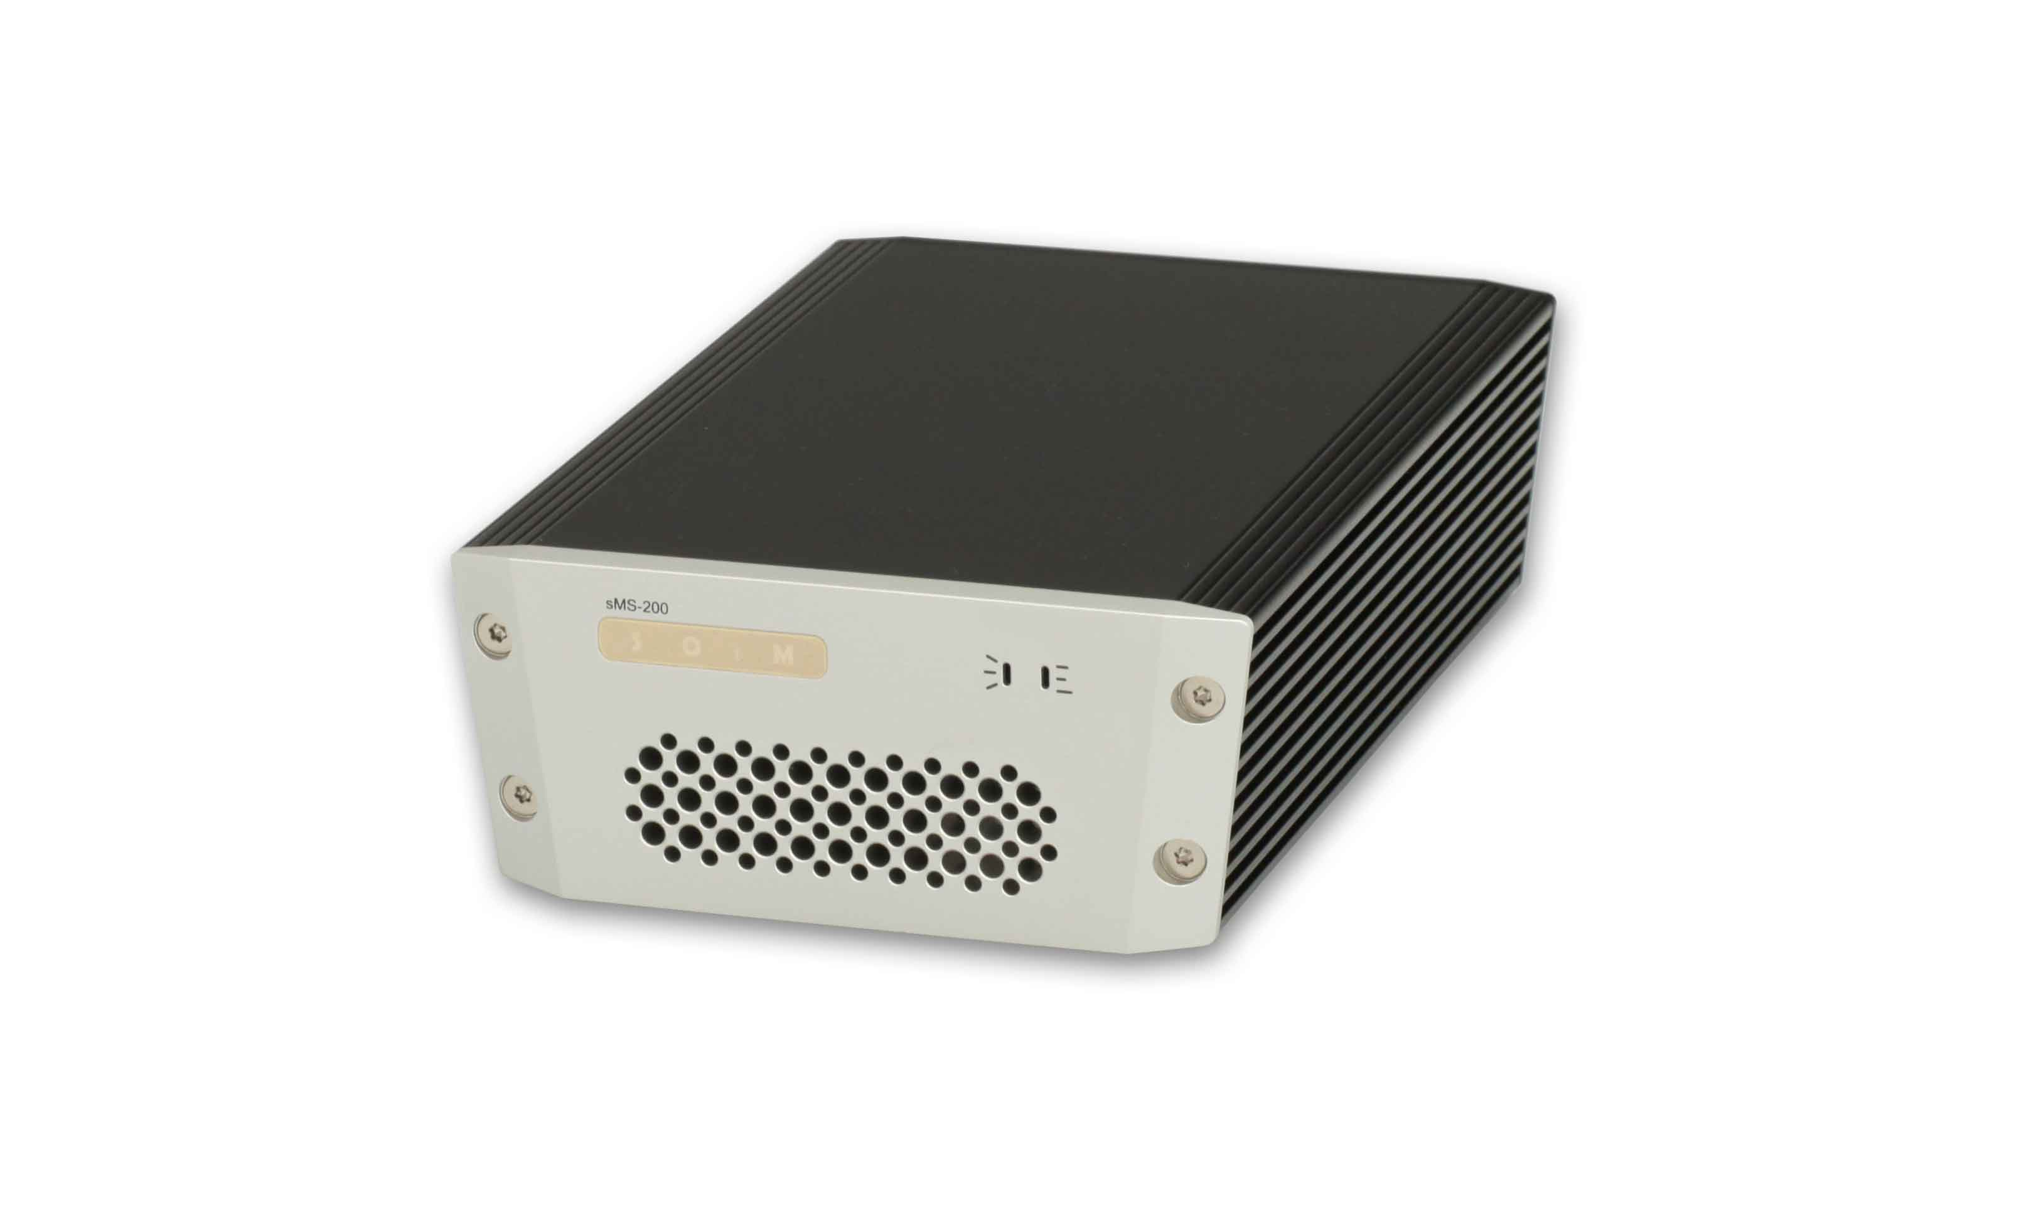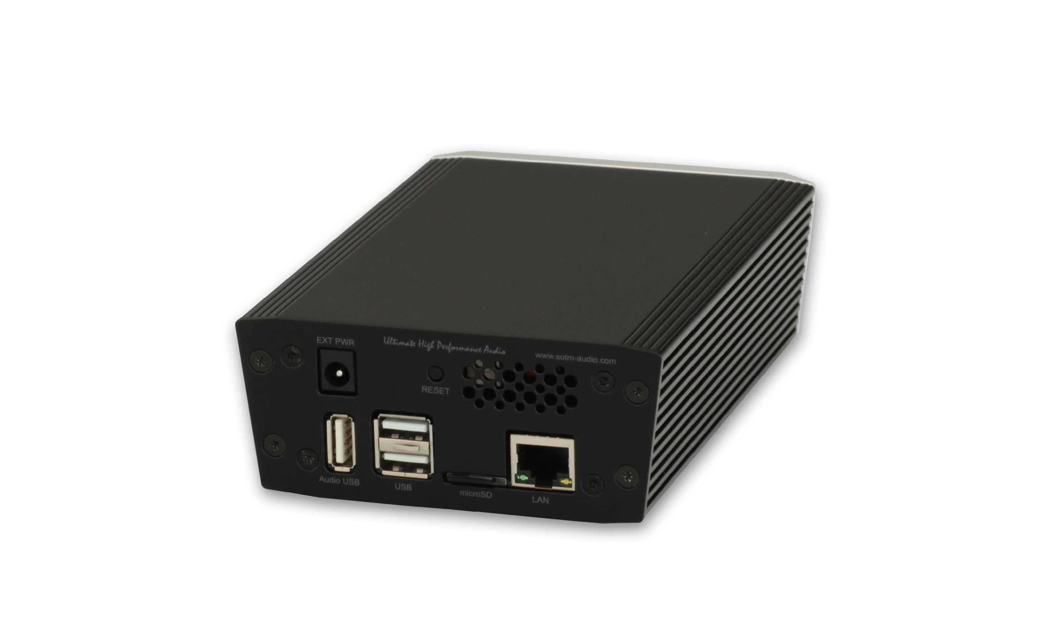
sMS-200 is a new generation of mini network player.
- Description
- Eunhasu usage
- sMS-200 User Guide

Exterior
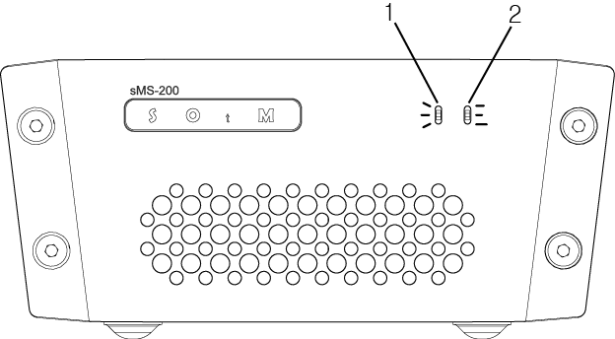
- Power and status indicator lamp: The lamp illuminates when the unit is powered ON and blinks according to its operational status.
- Operating indicator lamp: The lamp blinks according to its operational status.
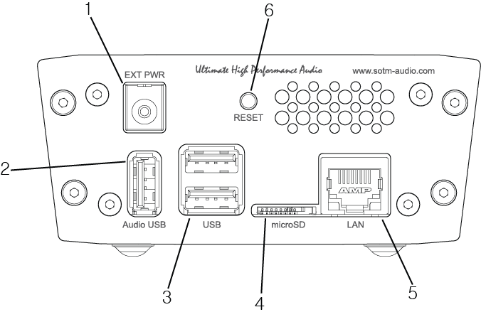
- Power input jack : Connect to a power supply.
- High-End audio grade USB port : Connect to USB audio device.
- USB 2.0 port : Connect to USB storage device.
- microSD card connector : The micro SD card which the product OS is loaded on is inserted.
  - Caution: do not pull out the micro SD card while the unit is powered on. Product might be damaged.
- LAN port : Connect to a router by network cable.
- Reset switch : Reboot the product by force.

