Make the USB installation disk

Download the Eunhasu ISO image file
- [Eunhasu ISO image file]

Download Rufus program
- Download Rufus V3.4

Preparation
- Prepare a 8GB(or above size) USB disk
- Write in DD Image mode
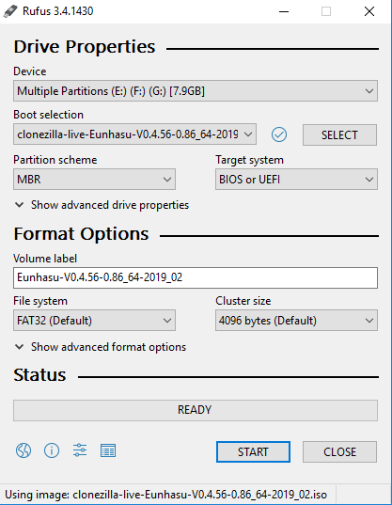
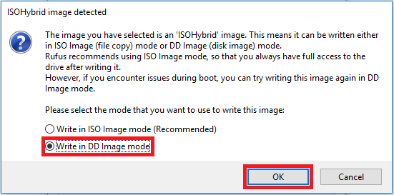

Install Eunhasu OS to the sMB-Q370

Connect the USB disk to the USB port of the sMB-Q370

Connect a LCD monitor by a HDMI cable to the sMB-Q370

Connect a USB keyboard to the sMB-Q370 and turn on the PC

Hit a F7 button continuously while booting to go to booting disk selection windows

Select the USB disk and continue booting

Select the first string in Clonezilla windows
Clonezilla live with img Eunhasu-V0.5.5_sMB-Q370_60G_2023-11-29-01-img (VGA 800x600)

Select the installation disk
- if your disk is M.2(NVME) Disk, select nvme0n1 or nvme0n2
- if your disk is SATA Disk, select sda or sdb

Select Y or hit Enter if asked whether to continue installations

Once finished installations, reboot the PC

Expand Partition

Login to Eunhasu console
(ID: root / P/W: sotmaudio)

Once Logged in, enter "mc" to continue

Access to /root/install folder
1) if you use M.2(NVME) Disk, run setup_nvme.sh file. 2) if you use SATA Disk, run setup_sata.sh file.

Reboot the sMB-Q370 PC

